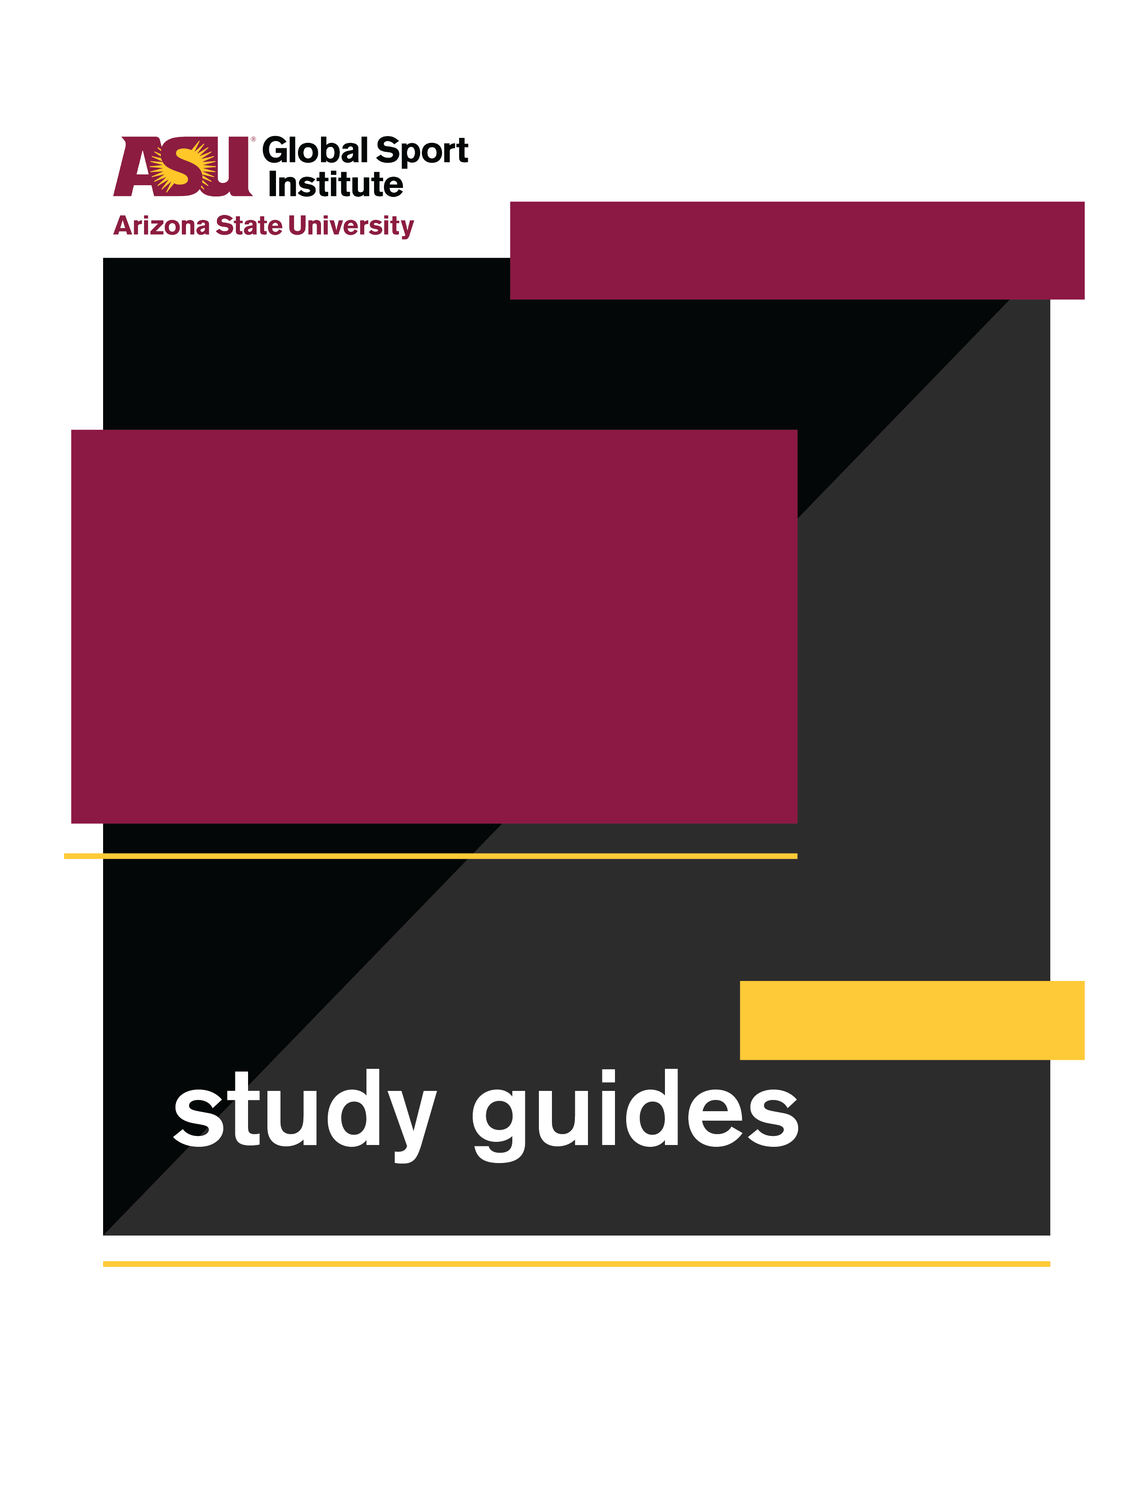
INDIVIDUAL
VIEWING GUIDE
This study guide was created by the Global Sport Institute at Arizona State University. https://globalsport.asu.edu
Wind and Waves

Directed by
Pamela Johnson
Documentary Study Guides

Wind and Waves – Individual Viewing Guide
https://globalsportmatters.com/video/2018/11/20/wind-and-waves-are-the-ultimate-proving-ground-for-adventurers/

Watch and Answer
While watching this 12-minute documentary, write down answers to the following questions. You can finish your answers after the documentary if you need more time. Answers are pasted at the end of this viewing guide for your reference.

- What is Oceans Seven? Write a few of the locations/swims.

- What different coaches/doctors were part of Antonio’s team?

- What did Antonio sell when he was younger?

- What are some of the biggest risk factors and challenges during Oceans Seven?

- What are some of the differences between pool swimming and open water swimming?

- What was the purpose of swimming across the U.S.-Mexico border?

- How many people had finished the Oceans Seven before Antonio did in 2017?

Think About It

- In the documentary, Antonio said, “You have to have a rock. It doesn’t have to be sports like it is for me, swimming, but everybody needs a rock to hold on, because life is full of surprises.”
- What do you think he means by this? (1-2 sentences)

- What are 2-3 examples of “a rock” that you or people you know have, and how do they help you/others in life?

- Antonio had a team of four coaches and doctors. What are a few ways his team supported him? Do you think he could have completed Oceans Seven without them? Why or why not? (4-6 sentences)

- Contemplate the phrase “water connects all of us,” and think back to the image of the Mexico / U.S. border wall ending in the water. Does seeing the water flow over the wall and watching people swim from one side to the other make the border feel any different to you? Why or why not? (3-4 sentences)

Apply It

- Choose Your Team: If you were putting together a team for a major goal or project in your career or hobby (like Oceans Seven was for Antonio), who would need to be part of it? Think about the expertise, support, and resources you would need. List 3-5 job titles you’d have on your team, and write 1-2 sentences describing what that person would do.
  - Expertise, support, and resources needed:

  - Job titles (3-5) and 1-2 sentences describing each:
1.

2.

3.

4.

5.

- Find Your Inspiration: Antonio said, “dreams don’t have an age.” When he finished the Oceans Seven challenge, he was 58 years old. Who is someone you admire because they accomplished something amazing at an impressive age, old or young?

- Who is it, and what did they accomplish?

- How did they do it (preparation, teamwork, etc.)?

- What lessons have you learned from them to apply to your life?

- What is a goal you would like to achieve?

- How can the lessons you learned from the person you admire help you achieve this goal?

- Make Your Impact: Antonio and many other swimmers from around the world gathered for a cause they believed in to swim across the Mexico / U.S. border. Think about your career, passion, hobby, etc. What’s a way you can use it for a positive impact? This impact could be local, regional, or global.

  - What is the career/passion/hobby?

  - List 2-3 potential ways you can use it for a positive impact. Think about community needs or local and global issues that you can connect to your career/passion/hobby.

  - Choose one of those ways to make an impact, and answer the following with 2-3 sentences each:
    - What is the goal of the impact you want to make? It can be big or small!

    - Who/what will benefit from achieving this goal, and how?

    - What physical/tangible resources do you need?

    - Who else could help you achieve this goal? They can be specific or general (e.g. lawyer, photographer).

    - What are 2-3 potential challenges you could face, and how would you plan to overcome them?

    - What are the first steps you need to take to make this impact?

Conclusion

- What did you learn about open water swimming?

- What did you learn about what is needed to accomplish a major goal?

- How might greater awareness about the issues you learned about improve the world?

Worksheet Answer Key

- What is Oceans Seven?
  - Oceans Seven is essentially the swimming equivalent of the Seven Summits - swimming in open water between seven specific land masses.
  - Includes the North Channel, Cook Strait, Molokai Channel, English Channel, Catalina Channel, Tsugaru Strait, and Strait of Gibraltar.

- What different coaches/doctors were part of Antonio’s team?
  - A swim coach, strength coach, sports doctor, and a mental coach

- What did Antonio sell when he was younger?
  - Speedo products

- What are some of the biggest risk factors and challenges during Oceans Seven?
  - Bad weather, low water temperatures, jellyfish and other marine life, powerful waves, rocks

- What are some of the differences between pool swimming and open water swimming?
  - Pools have lanes, comfortable temperature, and shelter from weather. Open does not have these things, and swimmers must know which direction to swim.
      - Resources for transitioning from pool to open water swimming:
        - Team USA | Translating Pool Swimming to Open Water Swimming
        - Swimming World Magazine | 5 Major Differences Between Open Water Swimming and Pool Swimming

- What was the purpose of swimming across the U.S.-Mexico border?
  - It was an attempt to show that we are interconnected and highlight “that water connects all of us.”
  - The swimmers also raised money and awareness for the Colibrí Center for Human Rights in Tucson, AZ.
    - Los Angeles Times | Athletes swim across U.S.-Mexico border in immigrant-rights protest
    - https://colibricenter.org/

- How many people had finished the Oceans Seven before Antonio did in 2017?
  - 6 (he was the 7th)
  - As of April 2020, 21 people finished Oceans Seven (Longswim Database | Oceans Seven)

