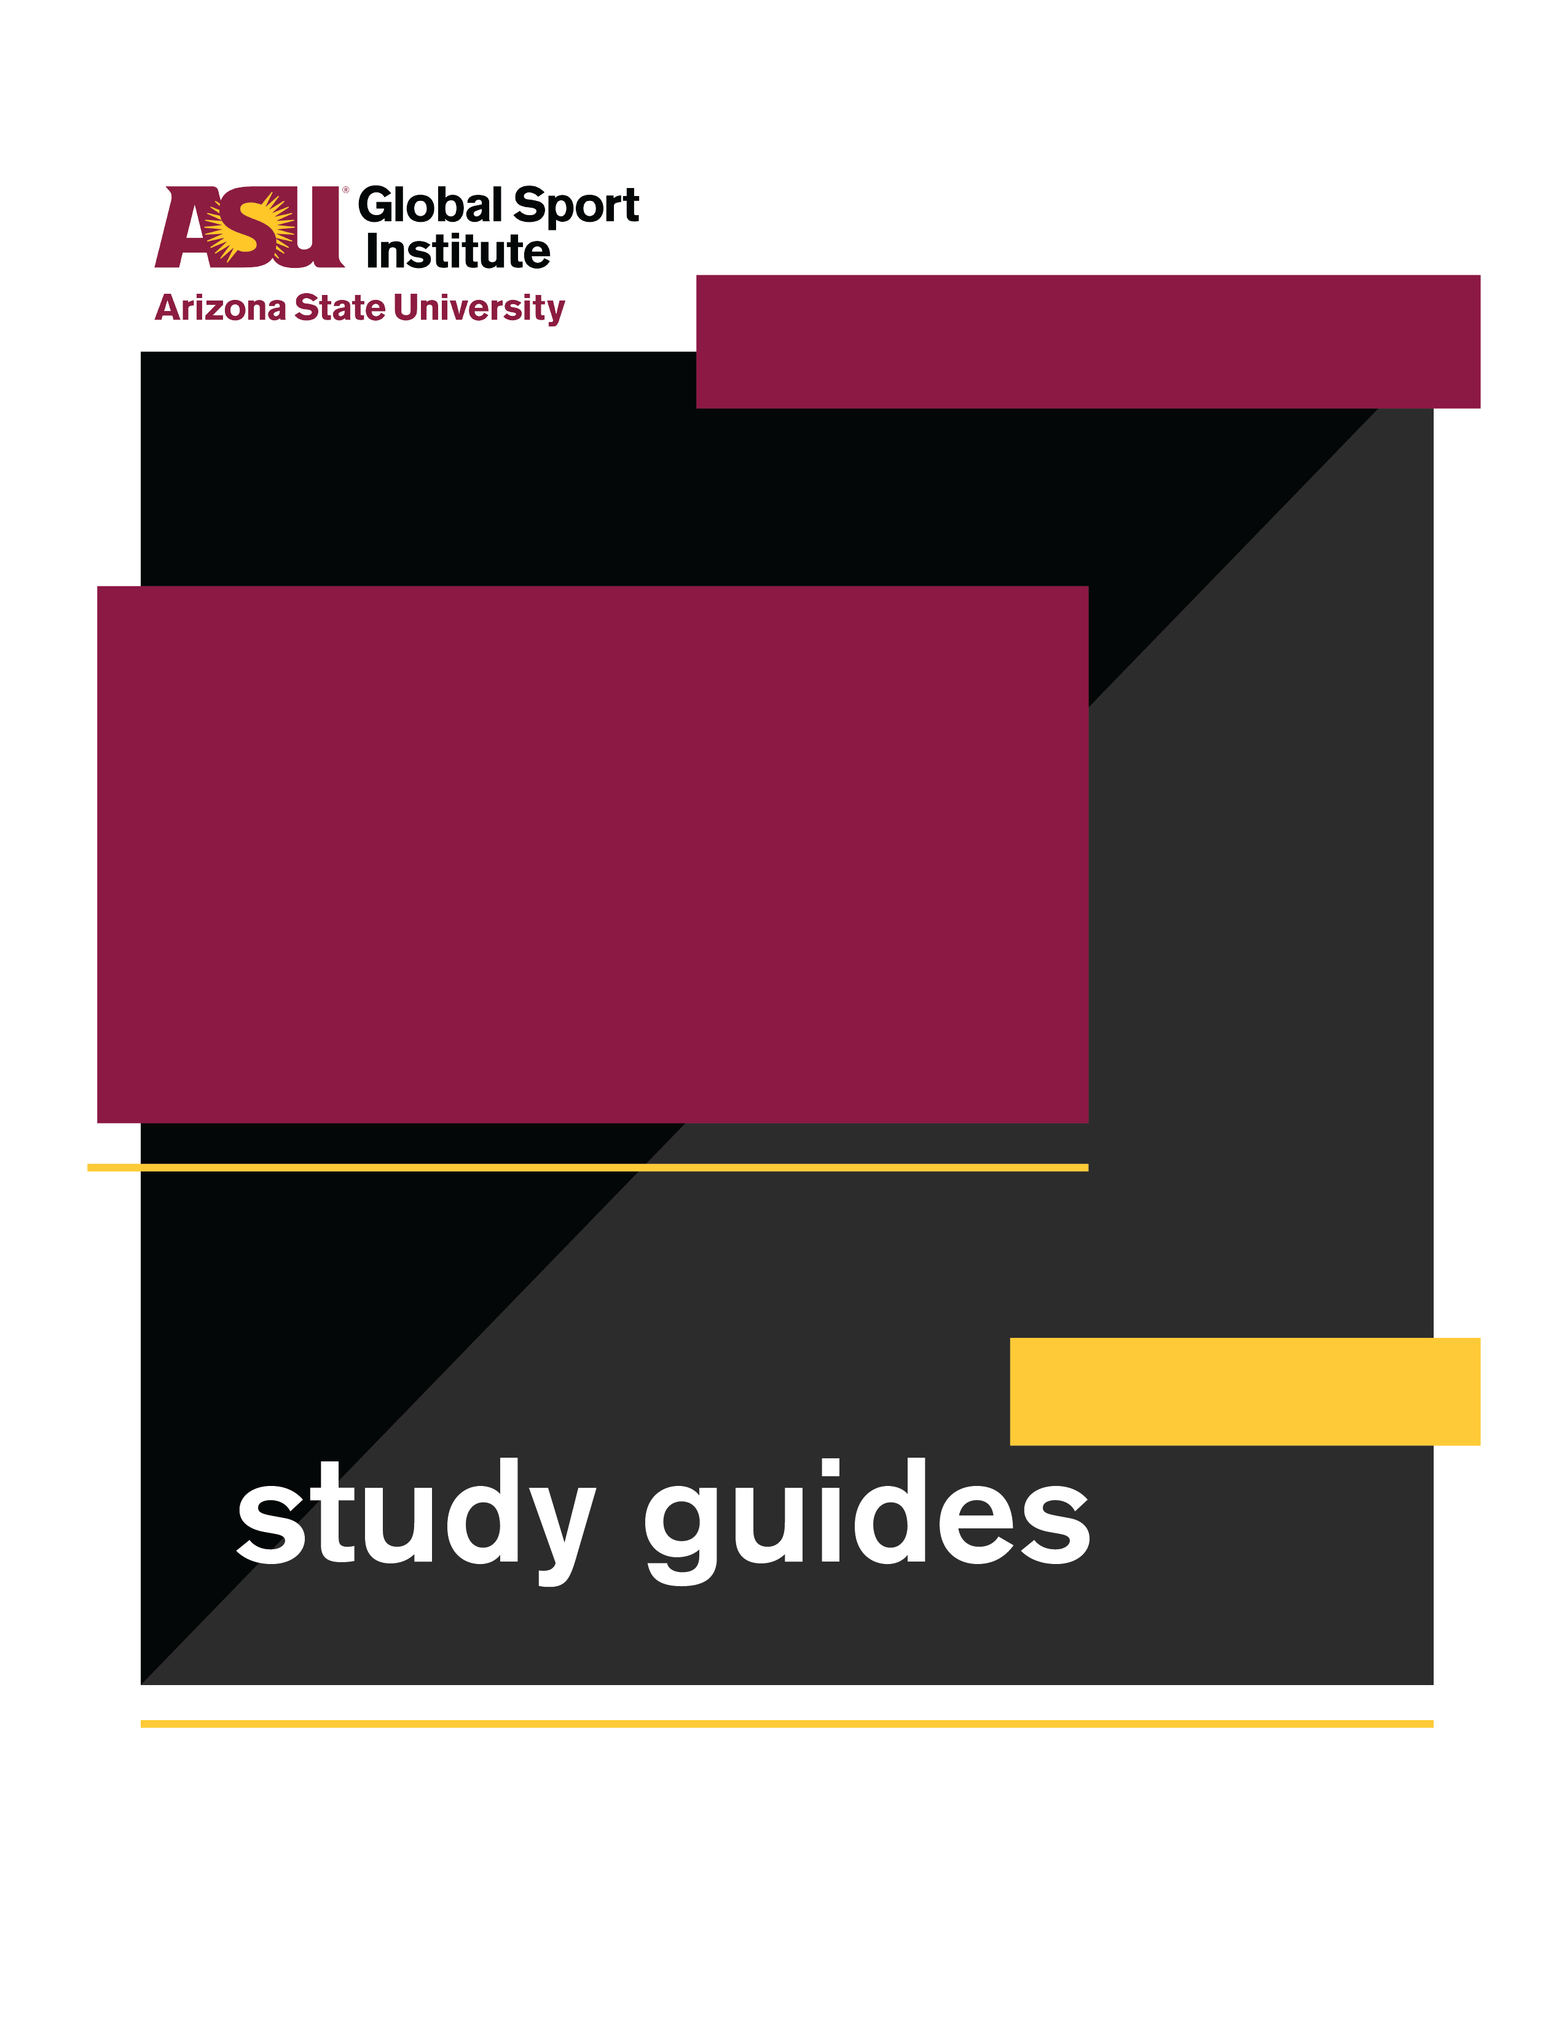
GROUP WORKSHEET
This study guide was created by the Global Sport Institute at Arizona State University. https://globalsport.asu.edu
Wind and Waves

Directed by
Pamela Johnson
Documentary Study Guides

Wind and Waves – Group Worksheet
https://globalsportmatters.com/video/2018/11/20/wind-and-waves-are-the-ultimate-proving-ground-for-adventurers/

Answer each of the following questions with bullet points or short sentences as you watch the 12-minute documentary. You’ll have a few minutes after watching to finish answering.

- What is Oceans Seven? Write a few of the locations/swims.

- What different coaches/doctors were part of Antonio’s team?

- What did Antonio sell when he was younger?

- What are some of the biggest risk factors and challenges during Oceans Seven?

- What are some of the differences between pool swimming and open water swimming?

- What was the purpose of swimming across the U.S.-Mexico border?

- How many people had finished the Oceans Seven before Antonio did in 2017?

Discussion Activities - wait until your teacher prompts you to start this section

- Choose Your Team: If you were putting together a team for a major goal or project in your career or hobby (like Oceans Seven was for Antonio), who would need to be part of it? Think about the expertise, support, and resources you would need. List 3-5 job titles you’d have on your team, and write 1-2 sentences describing what that person would do.

  - Expertise, support, and resources needed:

  - Job titles (3-5) and 1-2 sentences describing each:
1.

2.

3.

4.

5.

- Find Your Inspiration: Antonio said, “dreams don’t have an age.” When he finished the Oceans Seven challenge, he was 58 years old. Who is someone you admire because they accomplished something amazing at an impressive age, old or young?

- Who is it, and what did they accomplish?

- How did they do it (preparation, teamwork, etc.)?

- What lessons have you learned from them to apply to your life?

- What is a goal you would like to achieve?

- How can the lessons you learned from the person you admire help you achieve this goal?

- Make Your Impact: Antonio and many other swimmers from around the world gathered for a cause they believed in to swim across the Mexico / U.S. border. Think about your career, passion, hobby, etc. What’s a way you can use it for a positive impact? This impact could be local, regional, or global.

  - What is the career/passion/hobby?

  - List 2-3 potential ways you can use it for a positive impact. Think about community needs or local and global issues that you can connect to your career/passion/hobby.

  - Choose one of those ways to make an impact, and answer the following with 2-3 sentences each:
    - What is the goal of the impact you want to make? It can be big or small!

    - Who/what will benefit from achieving this goal, and how?

    - What physical/tangible resources do you need?

    - Who else could help you achieve this goal? They can be specific or general (e.g. lawyer, photographer).

    - What are 2-3 potential challenges you could face, and how would you plan to overcome them?

    - What are the first steps you need to take to make this impact?

