LESSON PLAN
This study guide was created by the Global Sport Institute at Arizona State University. https://globalsport.asu.edu
United We Stand:
The Ali Summit

Directed by Kirk Fraser
Documentary Study Guides

United We Stand: The Ali Summit - Lesson Plan
https://www.youtube.com/watch?v=VIGqdOJ2cuc

Black print: Instructions for the teacher
Blue print: Spoken instructions from teacher to participants

- Historical Background (35-40 minutes)
  - Small group breakouts to research specific terms and topics with pre-selected resources
    - What was the Vietnam War, and how did Americans feel about it?
      - Resource A
      - Resource B
    - How did the draft work?
      - Resource A
      - Resource B
    - What is a conscientious objector?
      - Resource A
      - Resource B
    - What is identity foreclosure?
      - Resource A
      - Resource B
  - Each small group fills out their section of the worksheet with facts, examples, and what they identify as additional interesting information
  - Each small group shares what they wrote with the full group
  - Ask full group: Who are some of the most famous, influential athletes in the U.S. right now?
    - Make a list on a whiteboard, PPT slide, giant notepad, etc.
    - Keep this list in mind as we watch the documentary.
  - When you notice instances of identity foreclosure in the documentary, write them down for later discussion.
If assigning reading/viewing materials to complete before watching documentary as a group
- Setting the Historical Context (15 minutes)
  - Participants assigned reading/viewing resources on the following before coming to class
    - Vietnam War and American sentiment
    - How the draft worked
    - Conscientious objectors
    - Identity foreclosure
    - NFL waivers in 1960s
    - NFL salary statistics in 1960s vs present
    - Excerpts from: Message to the Black Man (Elijah Muhammad), Redemption Song (Muhammad Ali), 40 Million Dollar Slaves (William C. Rhoden), Our War (David Harris)
  - Very briefly go through each topic 1-by-1 to ask about questions and anything that surprised them
  - Ask full group: Who are some of the most famous, influential athletes in the U.S. right now?
    - Make a list on a whiteboard, PPT slide, giant notepad, etc.
    - Keep this list in mind as we watch the documentary.
  - When you notice instances of identity foreclosure in the documentary, write them down for later discussion.

- Show the documentary – press pause after each section for discussion questions
  - The Fight (2:25 – 5:05) – 15-20 minutes
    - Jim Brown said, “It was very difficult, because you had to decide when to speak up and when not to.” John Wooten said, “Dr. King, I will hurt the cause if I march.”
      - What did they mean by these statements?
      - If someone is thinking about the best way they can make a positive change in the world, what do they need to consider about themselves?
        - For example, compare Barack Obama, LeBron James, and yourself. What are some things each of these people can and cannot do because of who they are?
        - Should we all try to make change in the same way, or is it different for each person?
      - If you have influence like the men in the documentary, what considerations do you need to make to use that power most effectively?
  - The Union (5:05 – 7:50) – 15-20 minutes
    - Among African Americans at the time, there were many different opinions about how to fix racial injustice in the U.S. The athletes in this documentary may have disagreed on some things, but they found common ground in improving economic and educational opportunities in inner cities.
      - What are some of the different opinions about how to fix racial injustice in the U.S. today, and how do they conflict with each other?
        - Example – NFL player-activists publicly disagreeing on working with league or not
      - What is some common ground that people with these different opinions share, and how could it help unite people for the cause to fix racial injustice?
  - The War (7:50 – 10:13) – 15-20 minutes
    - Some of the men in the photo were drafted and went into the military, which meant taking time away from their athletic careers and potentially risking their lives. Ali refused to do this.
      - How do you think some of them felt about Ali refusing to do something they had to do?
      - What are some ways that listening to someone with a different opinion can benefit you? Suggested answers if needed:
        - It’s easy to think everyone who disagrees with us is stupid, selfish, or just a bad person, so we often don’t care what they have to say. Sometimes, we’re surprised by the reasons they believe what they believe, and even though we still disagree, we can respect them.
        - Listening helps you understand that person better so you can communicate with people who have that opinion.
        - Listening helps you find shared goals to work on together even if you don’t agree on some things.
      - Jim Brown said, “We’ve got to support him. Get the guys together…We would support him as a unit.”
        - What are some reasons you would support someone if you didn’t agree with them? Suggested answers if needed:
          - A shared cause is bigger than your opinion.
          - Internal disagreements shouldn’t stop progress on an important issue.

  - Group Activity – Who Was There? (20-25 minutes)
    - Before the last couple segments of the documentary, we have a group exercise. Get in your previous small groups. Look at the section on your worksheet titled “Who Was There?” There aren’t any names, but there is information about real people who were there and real people who were not there. In your groups, discuss, debate, and fill in each of the three blanks under each person. You can fill in your answers as an individual if you disagree with others in your group.
      - Why I would show up? ___________________
      - Why I would not show up? ____________________
      - Did I show up? ______
    - We will debrief your answers after we finish the documentary.

  - The Summit (10:13 – 14:32) – 15-20 minutes
    - What did you see related to identity foreclosure in this section? Consider conforming to expectations vs. exploring and committing to yourself. Suggested answer if needed:
      - Accepting the expectation of who you are supposed to be vs. exploring and committing to who you believe yourself to be. One athlete said, “You were drafted. All of us have served our military obligation,” but Ali didn’t accept that expectation. He challenged it because it didn’t line up with who he believed himself to be.
    - What are some benefits of listening to others’ experiences, even if you disagree with them? Suggested answers if needed:
      - “[Religion] was more important to him than anything else. That kind of blew my mind, so I had to step back, because what he was saying now was so much stronger than me.” This athlete realized that Ali had a respectable, important reason for his decision, so he gained respect for him.
      - “Over the dollars, I got principles.” This athlete explained that his integrity was worth more to him than money. Without hearing that, you might think he was stupid to give up his career like that.
    - Our priorities affect our decision-making, and Walter Beach said, “I didn’t value that role as a professional football player as much as I valued a role as a man supporting Ali. I knew I wasn’t going to play football all of my life, but I knew the rest of my life, I had to be a man.”
      - How does this statement display identity foreclosure?
      - This quote shows how Beach’s priorities affected his decision to support Ali at the Summit. What do you prioritize about yourself? Write some of these things down under “What do I prioritize about myself?” on the worksheet. It’s important for us to think about this now so that when it’s time to make a decision, we’re prepared and not swayed by what feels easier at that moment.
      - Put yourself in Beach’s shoes. If you had known what you could lose from supporting Ali, would you have gone to the Summit? Be honest with yourself!
  - The Fallout (14:32 – 18:30) – 20-25 minutes
    - Should the term "owner" be dropped? How might Walter Beach’s experience add to the conversation? See this related article.
    - How do you feel about Walter Beach’s story about how the team owner thought he owned Beach?
    - Do you see any current or recent examples of what happened with Walter Beach being blackballed through waivers? Suggested answer if needed:
      - Colin Kaepernick blackballed by owners
    - Let’s reveal who was who from the “Who Was There” activity.
      - Read from answer sheet and show PPT slide
      - What’s your initial feedback on seeing this?
        - For “Did I show up?”, how many did you get right?
        - Did anyone show up who you thought would not? Why do think they showed up?
        - Did anyone not show up who you thought would? Why do you think they didn’t?
          - Explain why baseball players did not show up
          - If students don’t prompt discussion about no women, ask them why they think there were not any.
        - Now that you know who did and didn’t show up, what do you think about their priorities, motivations, and decisions?
      - Now we’re going to dive into a different part of what happened at the Ali Summit.
Activity if you have an extra 30 minutes
Civil Dialogue (30 minutes)
Topic options:
- Should US Women’s Soccer Sue the US Soccer Federation for Equal Pay?
- Should NFL players try to work with the league on racial injustice issues, or not?
Format and background information TBD

- “First Follower” Concept – 15-20 minutes
  - Being the first person to talk about an issue publicly, like Muhammad Ali, takes incredible courage. Being the second person – the first to join them – also takes incredible courage and is an essential step to build to a larger impact. This is because it gives credibility to the first person, makes them seem less crazy, and it reduces others’ hesitation to join by showing how to do it. We’re going to watch a short video that is obviously not as serious as the Ali Summit, but it has some similar ideas.
    - Show the video of “The Shirtless Dancing Guy.”
      - What are some similar examples from the documentary?
      - What about current examples? What has happened in society that reflects this video of the “shirtless dancing guy?” Suggested answers if needed:
        - Colin Kaepernick as the leader
        - Rachel Denhollander (first former gymnast to accuse Larry Nassar of sexual abuse)
        - Ashley Judd & Rose McGowan (among the first women to accuse Harvey Weinstein of sexual misconduct)
          - Who were the courageous first followers? What effect did they have?
  - Show a photo of whole Ali Summit group, and then an edited photo with just Ali.
    - What would have been different if Ali was there by himself?
      - For Ali
      - For media coverage
      - For public response

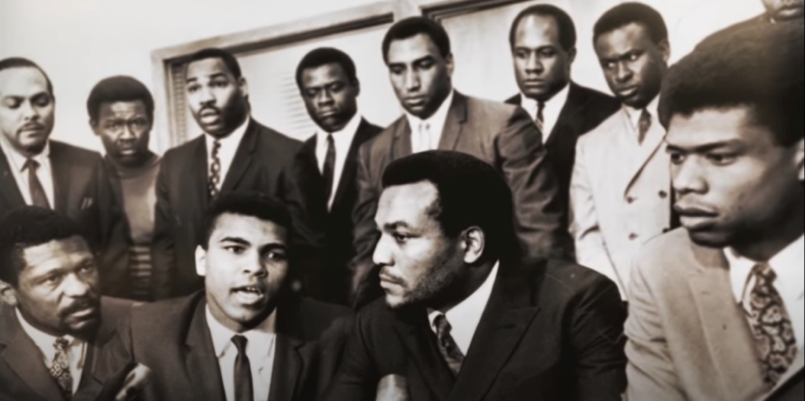
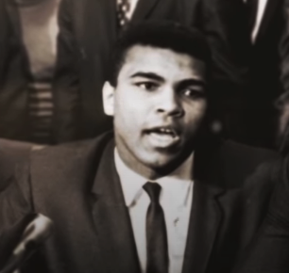

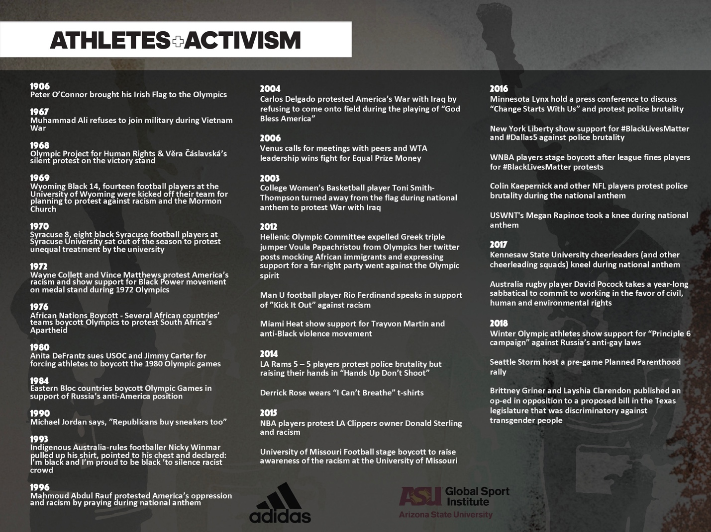

- Athlete activism historical timeline– 15-20 minutes
  - Now we’re going to honor the history of athlete activism that led to the Ali Summit and what has happened between then and now. Refer to the timeline on your worksheet.
    - Put up timeline PPT slide
  - What does the timeline show us about pioneers and followers?
  - Fill in the timeline with what you know. Are there other events missing?
  - Do athletes today have more or less to lose by being activists?
    - Consider social consequences.
    - Consider financial consequences.
    - Consider playing career consequences.
      - Example if needed: Colin Kaepernick talks about being blackballed by NFL owners in a similar way to Walter Beach.

- Conclusion – 5-10 minutes
  - What lessons does the Ali Summit hold for us?
    - Answers if needed: collective action, leverage, principles, duty and obligation, understanding history, listening, priorities
  - How much have you learned about the Ali Summit?
  - Do you think that many people know about the Ali Summit and its place in history and change? How might greater awareness of the Ali Summit help improve the world?
  - Reference the “Additional Reading List” on their worksheets.

