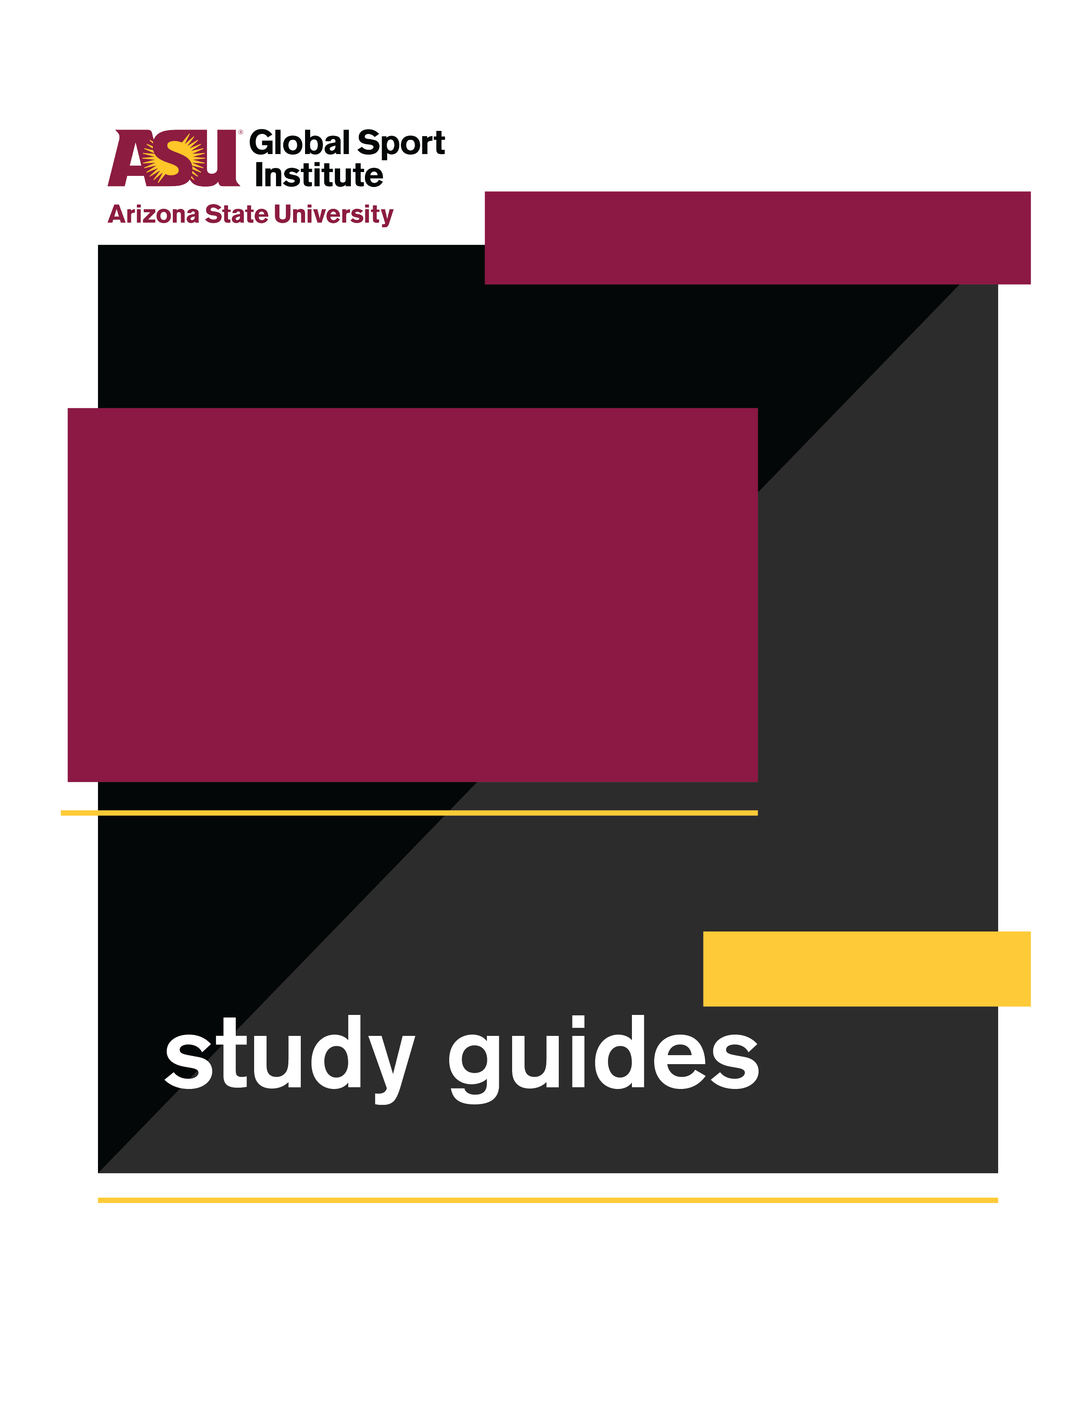
INSTRUCTOR’S ANSWERS
This study guide was created by the Global Sport Institute at Arizona State University. https://globalsport.asu.edu
United We Stand:
The Ali Summit

Directed by Kirk Fraser
Documentary Study Guides

United We Stand: The Ali Summit – Instructor’s Answers
https://www.youtube.com/watch?v=VIGqdOJ2cuc

There were 11 people at the Ali Summit in Cleveland, Ohio in June 1967. See below for more information on each of the 11 who were there.

- Kareem Abdul-Jabbar (Lew Alcindor at the time)
Did I show up? YES

- Walter Beach
Did I show up? YES

- Jim Brown
Did I show up? YES

- Willie Davis
Did I show up? YES

- Wilma Rudolph
Did I show up? NO – why?

- Max Alvis
Did I show up? NO – why?

- Bill Russell
Did I show up? YES

- Willie Mays
Did I show up? NO – why?

- Carl Stokes
Did I show up? YES

- Shirley Chisholm
Did I show up? NO – why?

- John Wooten
Did I show up? YES

From “Stars at the Muhammad Ali Summit: Where are they now?” http://blog.cleveland.com/pdextra/2012/06/stars_at_the_muhammad_ali_summ.html

Kareem Abdul-Jabbar
In 1967, Lew Alcindor (who later became Kareem Abdul-Jabbar) was a sophomore at UCLA. He would become one of the greatest college and NBA players in history. Abdul-Jabbar won three NCAA Titles with UCLA, five NBA titles in the NBA, is the league's all-time leading scorer, and remains the only NBA player with six MVP awards. He was inducted into the Pro Basketball Hall of Fame in 1995. Abdul-Jabbar is the author of seven books. His latest is a children's book, "What Color is My World? The Lost History of African-American Inventors." His Skyhook Foundation is dedicated to inspiring youth to exercise their minds and realize the power of knowledge.

Muhammad Ali
Ali is one of the most recognizable faces in the world. Born Cassus Clay, he is considered one of the greatest boxers of all time. In 1967, Ali was stripped of his title, and his boxing license was suspended because he refused to serve in the Army and participate in the Vietnam War. The Supreme Court ruled in Ali's favor as a conscientious objector in 1971. Ali regained his title in 1973 with a victory over George Foreman. Ali, diagnosed with Parkinson's syndrome in 1984, has received numerous humanitarian awards from around the world.

Walter Beach
Beach's career as a defensive back began with the Boston Patriots in 1960. He played for the Browns from '63 to '66. He was part of the defense that shut out Johnny Unitas and the Baltimore Colts in the 1964 NFL Championship won by the Browns. Beach was out of football in '67. He worked as a paralegal for the Legal Aid Society in Cleveland that year. Beach is the CEO of Amer-I-Can. His autobiography, "Consider This," is due out later this year.

Jim Brown
Probably the greatest running back in NFL history. Brown, who retired in 1965, still holds several career records with the Cleveland Browns, including touchdowns and rushing yards. He was inducted in the Pro Football Hall of Fame in 1971. After football, Brown became an action star and appeared in dozens of movies. As an activist, Brown helped create the Negro Industrial Economic Union (later called the Black Economic Union), and Amer-I-Can, a program that helps gang members learn life management skills. The Browns ended Brown's role as executive adviser in 2010.

Willie Davis
One of the best defensive ends in the history of the NFL. Davis began his career with the Browns but he was traded to the Green Bay Packers in 1960. Davis played with the Packers until he retired after the '69 season. Davis played in five Pro Bowls, six NFL title games and two Super Bowls. He was inducted into the Hall of Fame in 1981. Davis, who received his MBA from the University of Chicago Graduate School of Business in 1968, is the president of All-Pro Broadcasting, which runs five radio stations across the country.

Curtis McClinton
McClinton was a star running back in the AFL with the Dallas Texans and the Kansas City Chiefs. He was the AFL's Rookie of the Year in 1962. McClinton scored the first AFL TD in a Super Bowl. Following his NFL career, McClinton became a registered banker. He graduated from Harvard University's Kennedy School of Government, received a master's degree from Central Michigan University and a doctorate from Miles College. He served as deputy mayor for Economic Development in Washington, D.C. He owns McClinton Development Company in Kansas City. "He also played football, the life of Curtis McClinton," is a soon-to-be-released book by Riley Horne.

Bobby Mitchell
The Browns drafted Mitchell in the seventh round of the 1958 NFL Draft. As a halfback, Mitchell teamed with fullback Jim Brown in the backfield. Mitchell last played for the Browns in 1961, then was traded to Washington in 1962 for the top draft pick, which the Browns used to select Syracuse running back Ernie Davis. Mitchell, who played his final season in 1968, remained with Washington as a pro scout and later moved up to assistant GM. Mitchell left the Redskins in 2008. For 32 years, Mitchell has hosted the Bobby Mitchell Hall of Fame Classic, an annual golf fundraiser that benefits the Leukemia & Lymphoma Society.

Bill Russell
Russell became player/coach of the Boston Celtics during the 1966-67 season. He became the first black man to ever coach a major American sports franchise. The Celtics, under Russell as a player or a coach, dominated the NBA during his era. Russell has 11 NBA rings. He was inducted into the Pro Basketball Hall of Fame in 1975. Despite being one of the greatest players of his time, Russell encountered bouts of racism in Boston. He was active in the Civil Rights Movement and marched with Martin Luther King Jr. Russell received the Presidential Medal of Freedom from President Barack Obama in 2010.

Jim Shorter
The Browns drafted Shorter, a defensive back, in the 14th round of the 1962 draft. Shorter left the Browns after the 1963 season. He played three seasons with Washington, where he was roommates with wide receiver Billy Hunter, now executive director of the NBA's players association. Shorter died in 2000.
Carl Stokes
Stokes was an attorney and a member of the Ohio House of Representatives in 1967. In 1968, he became the first black mayor of a major city (Cleveland). As mayor, Stokes increased the city's income tax and helped improve schools, housing, and other city projects. Stokes was also responsible for the "Cleveland Now!" program, a privately funded organization to aid a wide range of community needs. After serving as mayor (1968-71), Stokes was a broadcaster, judge and served as U.S. Ambassador to the Republic of Seychelles. Stokes died in 1996.

Sid Williams
Williams began his career as a linebacker for the Browns in 1964. He also played with Washington, Baltimore and Pittsburgh. Williams was a member of the BEU. Following his stint in the NFL, Williams started as a business developer with the Black Economic Union in Los Angeles, served as a legislative aide in the Los Angeles city council, and was project manager of an LA community redevelopment agency. Williams, who is married to California Rep. Maxine Waters, served as the Ambassador to the Bahamas from 1994-98.

John Wooten
The Browns drafted Wooten in the fifth round of the 1959 NFL Draft. An offensive lineman, he helped lead the way for Jim Brown. Wooten, executive director of the Black Economic Union, was in his last season with the Browns in '67 and finished his playing career in '68 with Washington. Wooten became the director of pro scouting with the Cowboys from 1975-91 and also worked for the NFL and the Baltimore Ravens. He's the president of Wooten Printing and serves as chairman of the Fritz Pollard Alliance.

