INDIVIDUAL
VIEWING GUIDE
This study guide was created by the Global Sport Institute at Arizona State University. https://globalsport.asu.edu
United We Stand:
The Ali Summit

Directed by Kirk Fraser
Documentary Study Guides

United We Stand: The Ali Summit – Individual Viewing Guide
https://www.youtube.com/watch?v=VIGqdOJ2cuc

- Setting the Historical Context
  - Read/watch the following resources
    - Vietnam War and American sentiment
    - How the draft worked
    - Conscientious objectors
    - Identity foreclosure
    - NFL waivers in 1960s
    - NFL salary statistics in 1960s vs present

  - Who are some of the most famous, influential athletes in the U.S. right now? Write down this list, and keep it in mind as you watch the documentary.
      - ________________
      - ________________
      - ________________
      - ________________
      - ________________
      - ________________
      - ________________
      - ________________
      - ________________
      - ________________
  - When you notice instances of identity foreclosure in the documentary, write them down here.

- Watch the documentary – press pause after each section and write your answers to each question.
  - The Fight (2:25 – 5:05)
    - Jim Brown said, “It was very difficult, because you had to decide when to speak up and when not to.” John Wooten said, “Dr. King, I will hurt the cause if I march.” What did they mean by these statements?

    - If someone is thinking about the best way they can make a positive change in the world, what do they need to consider about themselves? For example, compare Barack Obama, LeBron James, and yourself. What are some things each of these people can and cannot do because of who they are?

    - Should we all try to make change in the same way, or is it different for each person?

    - If you have influence like the men in the documentary, what considerations do you need to make to use that power most effectively?

  - The Union (5:05 – 7:50)
    - Among African Americans at the time, there were many different opinions about how to fix racial injustice in the U.S. The athletes in this documentary may have disagreed on some things, but they found common ground in improving economic and educational opportunities in inner cities. What are some of the different opinions about how to fix racial injustice in the U.S. today, and how do they conflict with each other?

    - What is some common ground that people with these different opinions share, and how could it help unite people for the cause to fix racial injustice?

  - The War (7:50 – 10:13)
    - Some of the men in the photo were drafted and went into the military, which meant taking time away from their athletic careers and potentially risking their lives. Ali refused to do this.
      - How do you think some of them felt about Ali refusing to do something they had to do?

      - What are some ways that listening to someone with a different opinion can benefit you?

      - Jim Brown said, “We’ve got to support him. Get the guys together…We would support him as a unit.”
        - What are some reasons you would support someone if you didn’t agree with them?

Before watching more, do this activity: Who was there?

There were 11 people at the Ali Summit in Cleveland, Ohio in June 1967. Below, there is information about real people who were there and real people who were not there. In your groups, discuss, debate, and fill in each of the three blanks under each person. You can fill in your answers as an individual if you disagree with others in your group.

- In 1967, I was a star sophomore basketball player at UCLA during the team’s dynasty under Coach John Wooden. I led the team to three national championships and a 47-game winning streak, and I was very well-known and popular among the general public. I’m an African-American man.
Why I would show up?

Why I would not show up?

Did I show up? ______

- My professional football career as a defensive back began with the Boston Patriots in 1960. I started playing for the Cleveland Browns in 1963 and was still with them when the Ali Summit happened in June 1967. When the Browns won the 1964 NFL Championship, I was part of the defense that shut out Johnny Unitas and the Baltimore Colts. I’m an African-American man.
Why I would show up?

Why I would not show up?

Did I show up? ______

- I retired from the Cleveland Browns in 1966 and was widely regarded as the best running back in NFL history. I led the NFL in rushing yards for eight seasons. At the end of my playing career, I starred in my first movie and continued acting as soon as I retired. I was very famous and popular among the general public. I’m an African-American man.
Why I would show up?

Why I would not show up?

Did I show up? ______

- I was one of the best defensive ends in NFL history. I started with the Browns but was traded in 1960 to the Green Bay Packers, where I was playing during the summer of 1967. I was also working on my MBA from University of Chicago at this time. I’m an African-American man.
Why I would show up?

Why I would not show up?

Did I show up? ______

- I was considered the fastest woman in the world in the early 1960s, and I was the first Black woman to win three gold medals in a single Olympic games in 1960. I was named the Associated Press Woman Athlete of the Year twice, and by the summer of 1967 I had retired from track and field and was an educator and track coach. The public loved me, but I didn’t make much money as a female athlete at the time.
Why I would show up?

Why I would not show up?

Did I show up? ______

- I was in the middle of an All-Star season with the Cleveland Indians in the summer of 1967. I was with the team for many years, was a very strong hitter, and a star third baseman. I am a White man.
Why I would show up?

Why I would not show up?

Did I show up? ______

- I was the first African-American man to coach a major American sports franchise (the Boston Celtics), and I was a coach and player at the same time. I finished my first year doing this a few months before the summer of 1967. The Celtics were dominant when I was a coach and player with them – we won eight straight NBA championships. Obviously, I was famous, popular, and rich.
Why I would show up?

Why I would not show up?

Did I show up? ______

- I am one of the greatest baseball players of all time, and I played professionally for over 20 years. I was one of the first African-American players to integrate into Major League Baseball in the early 1950s. I missed almost two full MLB seasons when I was drafted into the Korean War. I was playing for the San Francisco Giants in the summer of 1967.
Why I would show up?

Why I would not show up?

Did I show up? ______

- I was an attorney for awhile, and in 1967 I was a member of the Ohio House of Representatives. I was also planning my political campaign to become the first African-American mayor of a major U.S. city (Cleveland) the next year. I wanted to improve housing, schools, and other projects in the city. I am a man. I was also in the U.S. Army in 1945-1946.
Why I would show up?

Why I would not show up?

Did I show up? ______

- I was a state representative in New York in 1967, but I was ramping up a campaign to be the first African-American woman to serve in U.S. Congress the next year. I was a former educator, and many of my biggest accomplishments in New York’s legislature helped African-American youth gain access to better education opportunities.
Why I would show up?

Why I would not show up?

Did I show up? ______

- The Cleveland Browns drafted me in the fifth round of the 1959 NFL Draft. I was nearing the end of my playing career as an offensive lineman in 1967, and I was the executive director of the Black Economic Union at the time.
Why I would show up?

Why I would not show up?

Did I show up? ______

  - The Summit (10:13 – 14:32)
    - What did you see related to identity foreclosure in this section? Consider conforming to expectations vs. exploring and committing to yourself.

    - What are some benefits of listening to others’ experiences, even if you disagree with them?

    - Our priorities affect our decision-making, and Walter Beach said, “I didn’t value that role as a professional football player as much as I valued a role as a man supporting Ali. I knew I wasn’t going to play football all of my life, but I knew the rest of my life, I had to be a man.”
      - How does this statement display identity foreclosure?

      - This quote shows how Beach’s priorities affected his decision to support Ali at the Summit. What do you prioritize about yourself? Write some of these things. It’s important for us to think about this now so that when it’s time to make a decision, we’re prepared and not swayed by what feels easier at that moment.

      - Put yourself in Beach’s shoes. If you had known what you could lose from supporting Ali, would you have gone to the Summit? Be honest with yourself!

  - The Fallout (14:32 – end)
    - Should the term "owner" be dropped? How might Walter Beach’s experience add to the conversation? See this related article.

    - How do you feel about Walter Beach’s story about how the team owner thought he owned Beach?

    - Do you see any current or recent examples of what happened with Walter Beach being blackballed through waivers?

    - Now visit this Google Doc to see the answers to the “Who was there?” activity.

- “First Follower” Concept
  - Being the first person to talk about an issue publicly, like Muhammad Ali, takes incredible courage. Being the second person – the first to join them – also takes incredible courage and is an essential step to build to a larger impact. This is because it gives credibility to the first person, makes them seem less crazy, and it reduces others’ hesitation to join by showing how to do it. This short video is obviously not as serious as the Ali Summit, but it has some similar ideas. Watch it now: “The Shirtless Dancing Guy.”
    - What are some similar examples from the documentary?

    - What about current examples? What has happened in society that reflects this video of the “shirtless dancing guy?”

  - Look at this photo of everyone at the Ali Summit versus one edited to just Ali.
    - What would have been different if Ali was there by himself?
      - For Ali

      - For media coverage

      - For public response

- Athlete activism historical timeline

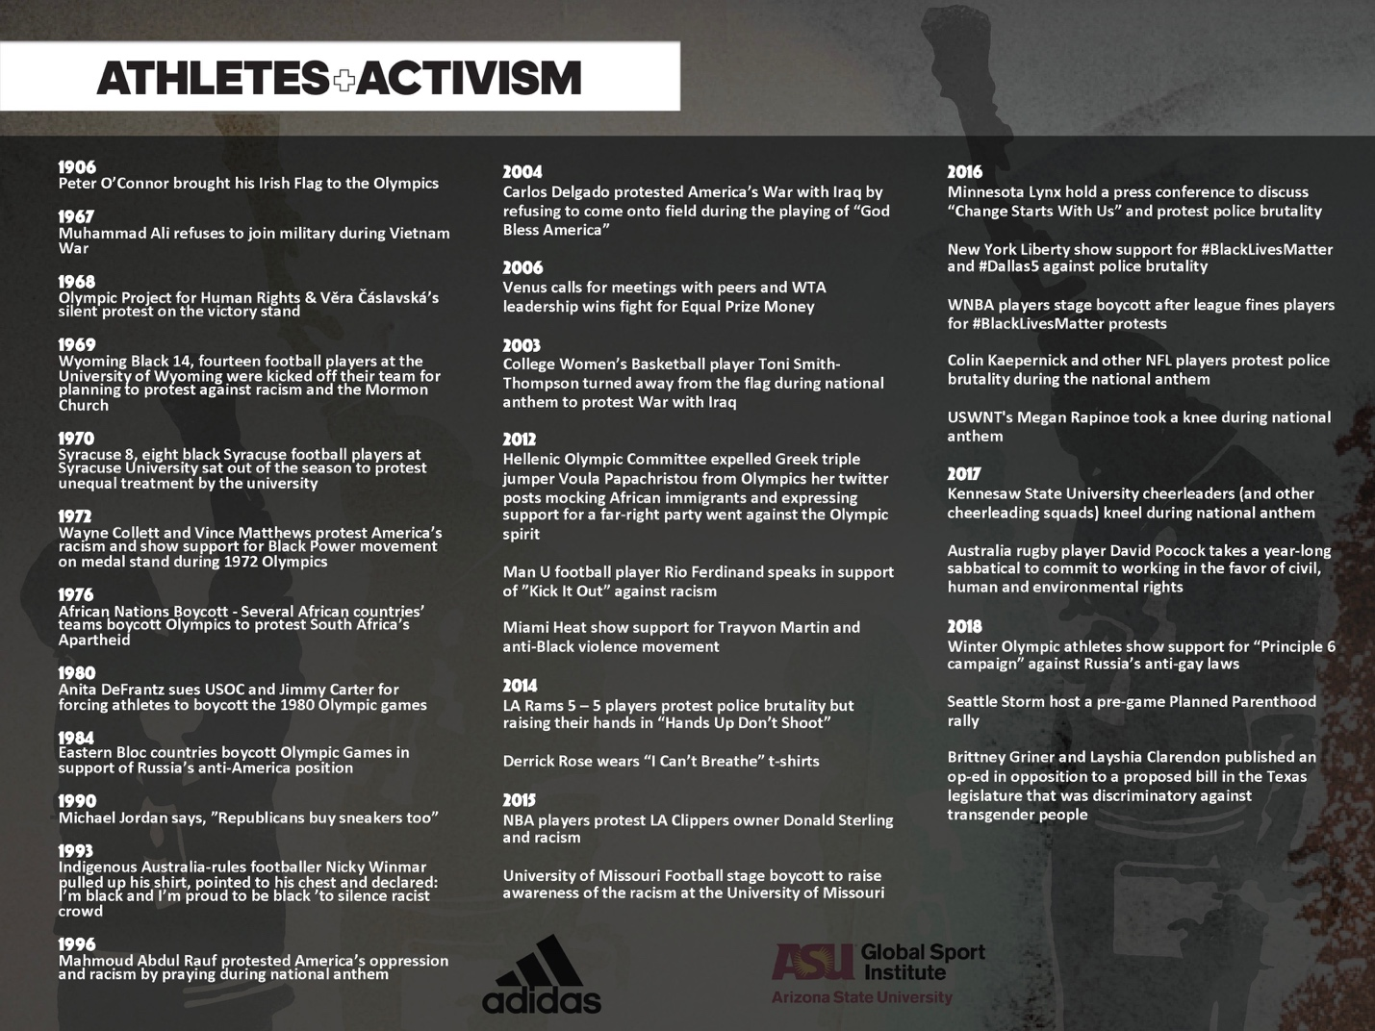

  - Look at this historical timeline of athlete activism. It shows what led to the Ali Summit and what has happened between then and now.

  - What does the timeline show us about pioneers and followers?

  - Fill in the timeline with what you know. Are there other events missing?

  - Do athletes today have more or less to lose by being activists? Consider the social, financial, and career consequences.

- Conclusion
  - What lessons does the Ali Summit hold for us?

  - How much have you learned about the Ali Summit?

  - Do you think that many people know about the Ali Summit and its place in history and change? How might greater awareness of the Ali Summit help improve the world?

  - Here’s a list of additional readings if you’re interested in a deeper understanding of the topics in this viewing guide.
    - Message to the Black Man (Elijah Muhammad)
    - Redemption Song (Muhammad Ali)
    - 40 Million Dollar Slaves (William C. Rhoden)
    - Our War (David Harris)

