GROUP WORKSHEET
This study guide was created by the Global Sport Institute at Arizona State University. https://globalsport.asu.edu
United We Stand:
The Ali Summit

Directed by Kirk Fraser
Documentary Study Guides

United We Stand: The Ali Summit – Group Worksheet
https://www.youtube.com/watch?v=VIGqdOJ2cuc

Historical Background

Group 1: What was the Vietnam War, and how did Americans feel about it?
- Facts:

- Examples:

Group 2: How did the draft work?
- Facts:

- Examples:

Group 3: What is a conscientious objector?
- Facts:

- Examples:

Group 4: What is identity foreclosure?
- Facts:

- Examples:

Identity Foreclosure in the Documentary – Your Observations Below

Who was There?

There were 11 people at the Ali Summit in Cleveland, Ohio in June 1967. Below, there is information about real people who were there and real people who were not there. In your groups, discuss, debate, and fill in each of the three blanks under each person. You can fill in your answers as an individual if you disagree with others in your group.

- In 1967, I was a star sophomore basketball player at UCLA during the team’s dynasty under Coach John Wooden. I led the team to three national championships and a 47-game winning streak, and I was very well-known and popular among the general public. I’m an African-American man.
Why I would show up?

Why I would not show up?

Did I show up? ______

- My professional football career as a defensive back began with the Boston Patriots in 1960. I started playing for the Cleveland Browns in 1963 and was still with them when the Ali Summit happened in June 1967. When the Browns won the 1964 NFL Championship, I was part of the defense that shut out Johnny Unitas and the Baltimore Colts. I’m an African-American man.
Why I would show up?

Why I would not show up?

Did I show up? ______

- I retired from the Cleveland Browns in 1966 and was widely regarded as the best running back in NFL history. I led the NFL in rushing yards for eight seasons. At the end of my playing career, I starred in my first movie and continued acting as soon as I retired. I was very famous and popular among the general public. I’m an African-American man.
Why I would show up?

Why I would not show up?

Did I show up? ______

- I was one of the best defensive ends in NFL history. I started with the Browns but was traded in 1960 to the Green Bay Packers, where I was playing during the summer of 1967. I was also working on my MBA from University of Chicago at this time. I’m an African-American man.
Why I would show up?

Why I would not show up?

Did I show up? ______

- I was considered the fastest woman in the world in the early 1960s, and I was the first Black woman to win three gold medals in a single Olympic games in 1960. I was named the Associated Press Woman Athlete of the Year twice, and by the summer of 1967 I had retired from track and field and was an educator and track coach. The public loved me, but I didn’t make much money as a female athlete at the time.
Why I would show up?

Why I would not show up?

Did I show up? ______

- I was in the middle of an All-Star season with the Cleveland Indians in the summer of 1967. I was with the team for many years, was a very strong hitter, and a star third baseman. I am a White man.
Why I would show up?

Why I would not show up?

Did I show up? ______

- I was the first African-American man to coach a major American sports franchise (the Boston Celtics), and I was a coach and player at the same time. I finished my first year doing this a few months before the summer of 1967. The Celtics were dominant when I was a coach and player with them – we won eight straight NBA championships. Obviously, I was famous, popular, and rich.
Why I would show up?

Why I would not show up?

Did I show up? ______

- I am one of the greatest baseball players of all time, and I played professionally for over 20 years. I was one of the first African-American players to integrate into Major League Baseball in the early 1950s. I missed almost two full MLB seasons when I was drafted into the Korean War. I was playing for the San Francisco Giants in the summer of 1967.
Why I would show up?

Why I would not show up?

Did I show up? ______

- I was an attorney for awhile, and in 1967 I was a member of the Ohio House of Representatives. I was also planning my political campaign to become the first African-American mayor of a major U.S. city (Cleveland) the next year. I wanted to improve housing, schools, and other projects in the city. I am a man. I was also in the U.S. Army in 1945-1946.
Why I would show up?

Why I would not show up?

Did I show up? ______

- I was a state representative in New York in 1967, but I was ramping up a campaign to be the first African-American woman to serve in U.S. Congress the next year. I was a former educator, and many of my biggest accomplishments in New York’s legislature helped African-American youth gain access to better education opportunities.
Why I would show up?

Why I would not show up?

Did I show up? ______

- The Cleveland Browns drafted me in the fifth round of the 1959 NFL Draft. I was nearing the end of my playing career as an offensive lineman in 1967, and I was the executive director of the Black Economic Union at the time.
Why I would show up?

Why I would not show up?

Did I show up? ______

What do you prioritize about yourself?

Athlete Activism Historical Timeline

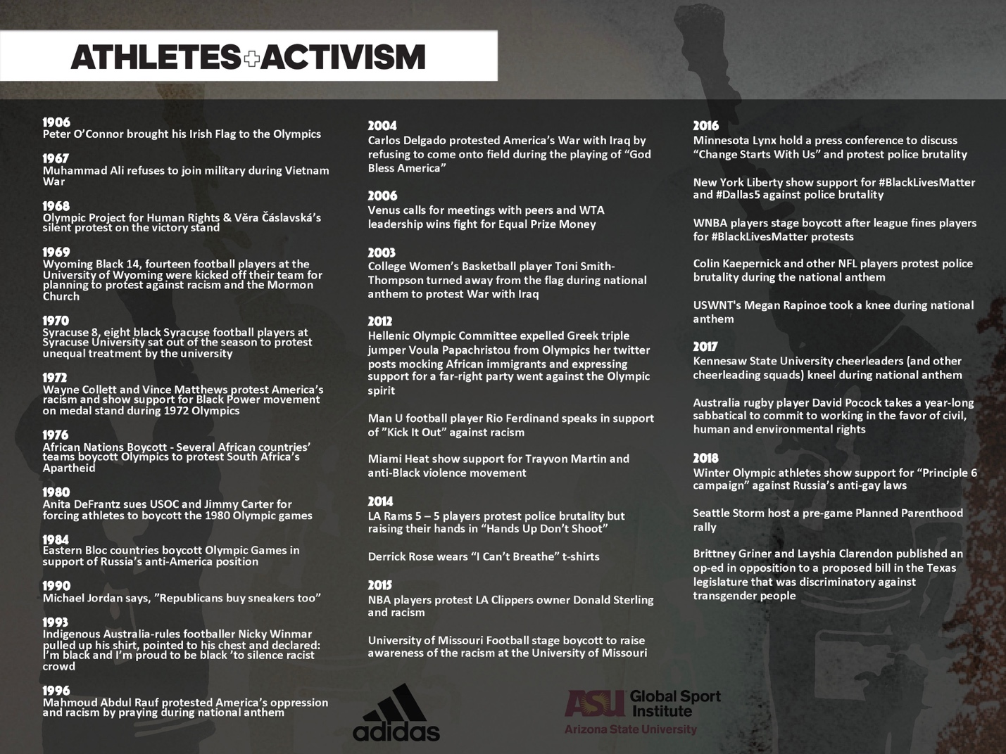

Additional Reading List

- Message to the Black Man (Elijah Muhammad)
- Redemption Song (Muhammad Ali)
- 40 Million Dollar Slaves (William C. Rhoden)
- Our War (David Harris)

