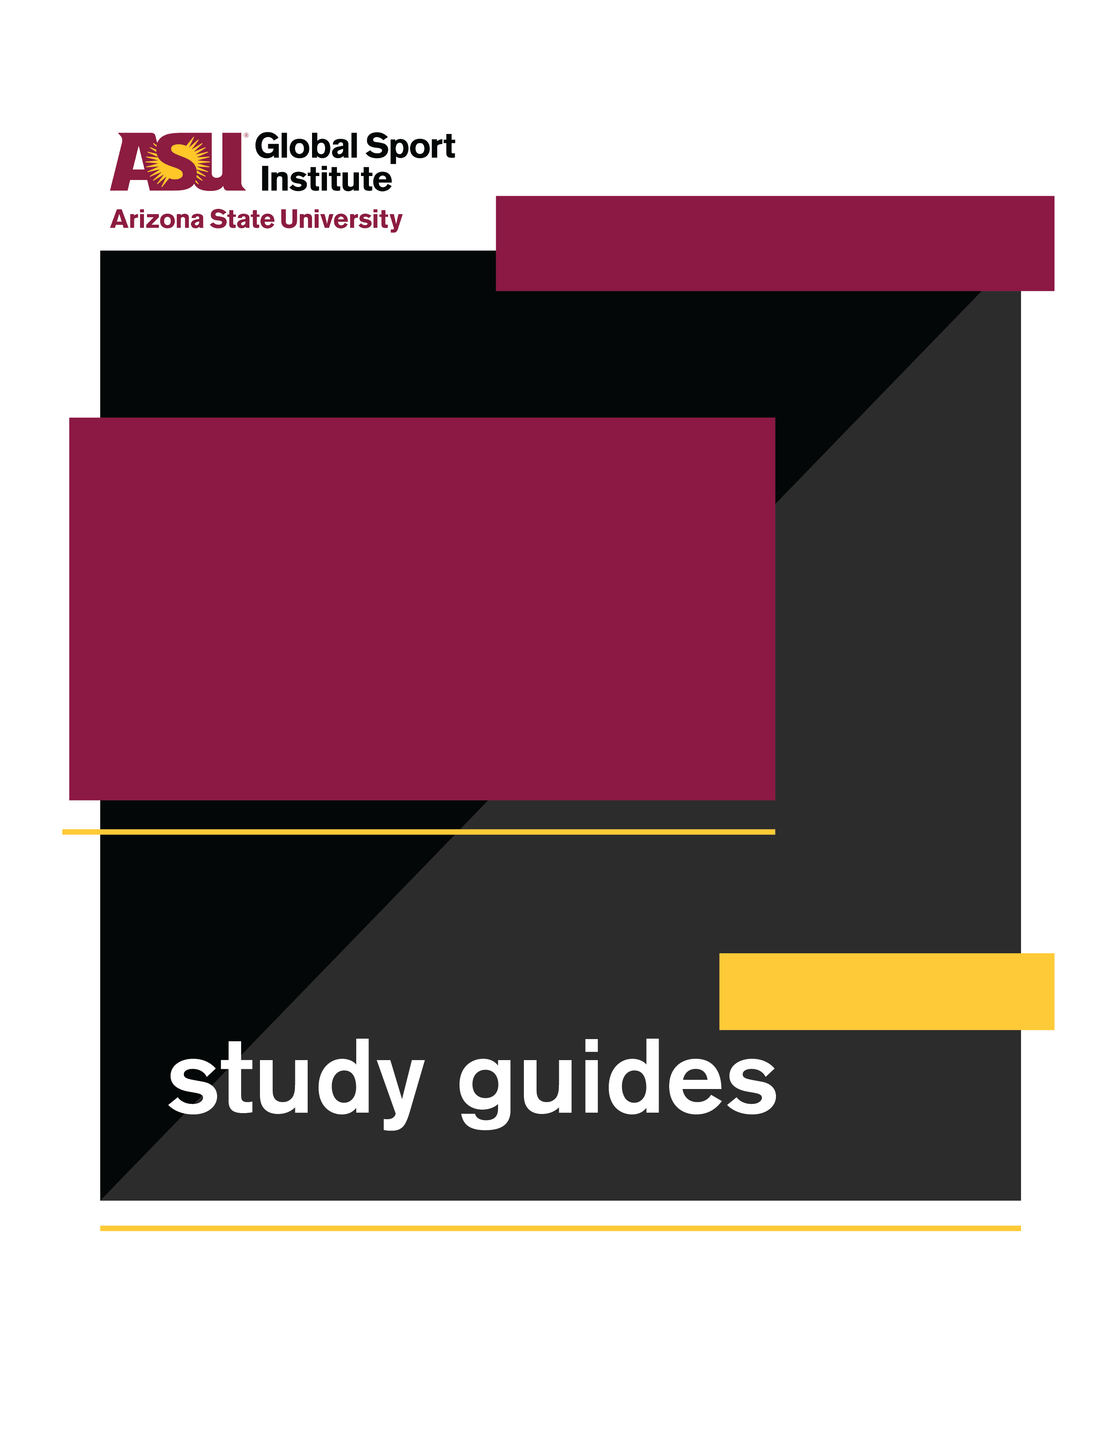
INDIVIDUAL
VIEWING GUIDE
Still Got Game

Directed by
Pamela Johnson
This study guide was created by the Global Sport Institute at Arizona State University. https://globalsport.asu.edu
Documentary Study Guides

Still Got Game – Individual Viewing Guide
https://www.youtube.com/watch?v=qU3S-BrADEM&feature=youtu.be

Watch and Answer
While watching this 7-minute documentary, write down answers to the following questions. You can finish your answers after the documentary if you need more time. Answers are pasted at the end of this viewing guide for your reference.

1. Why did the guys at Toberman park not let Anita play basketball with them?

2. How did education play an important role in Anita’s life?

3. What are some of Anita’s athletic achievements?

4. What are some challenges that Anita has faced throughout her life?

5. Why did Anita want to become a police officer, and what did she achieve as one?

6. How has women’s basketball changed in the last few decades, according to Anita?

7. What happened to the Women’s Professional Basketball League?

Think About It

- Anita talked about how when she was a teenager, older boys and men at the park didn’t let her play basketball with them because they didn’t want to injure her or hit her in sensitive areas. She wanted to play, though. Do you think they should have let her play with them at that time, or not? Explain why in 3-4 sentences.

- When the Women’s Professional Basketball League ended, Anita and others lost perhaps the best way to play their sport at its highest level. Have you ever had to stop doing something you loved when it wasn’t your choice? If so, what was it like for you? If not, think of what it would be like to have to quit something you love doing. Explain in 3-4 sentences.

- Anita was one of very few women of color in the LAPD. What do you think were some of the challenges she faced being different from the vast majority of her colleagues? List and explain 2-3 challenges.

- Anita’s first grade teacher told her she wasn’t “Anita Ortega.” Among other stereotypes she experienced, Anita said people assumed she should look a certain way because of her last name. How do you think experiences of ignorance and prejudice like this affect young children?

Apply It

1. Giving Back: At the end of the documentary when she’s talking about officiating basketball, Anita says, “I’m giving back to this sport, to the young athletes, because the sport gave a lot to me.”
a. What’s something that you love to do?

  - What has it given to you? List and explain 3-4 ways this interest/hobby has helped you, provided something you want or need, benefited you, etc.

  - How can you give back to this interest/hobby? List and explain 2-3 ways you can invest in it, improve it, provide it to more people, etc.

2. Learning About You: Anita’s father was Puerto Rican, but she lived in Los Angeles. She played for the Puerto Rican national basketball team at an international tournament when she was in college, and that’s when she went to Puerto Rico for the first time and met her grandmother.
a. What do you think it was like for Anita to visit Puerto Rico, meet some of her family, and play for the Puerto Rican team? Put yourself in her shoes and explain in 3-4 sentences.

  - Think of something about your family history, your hometown or neighborhood, or a loved one that you don’t know much about. This could include a language, family tree, the history of a place, a remarkable story about a relative, a cultural tradition, or something else.
    - What is it that you don’t know much about?

    - If you want to learn more about it, what are 2-3 ways you could start?

    - List and explain 3-4 ways that learning more about this thing would affect your perspectives, relationships, or daily life.

3. Race and Ethnicity: “Race is often perceived as something that's inherent in our biology, and therefore inherited across generations. Ethnicity, on the other hand, is typically understood as something we acquire, or self-ascribe, based on factors like where we live or the culture we share with others” (read more from this article here).

Anita talked about having a Black mother from the deep South, and a Puerto Rican father. She grew up in an area with a significant Mexican population and cultural influence.
a. How do you think these factors affected Anita’s identity and experience growing up? Explain in 2-3 sentences.

  - Using the quoted paragraph above as a reference:
    - What is your race? Why?

    - What is your ethnicity? Why?

  - Have you ever thought about the difference between race and ethnicity? What does it make you think about related to who you are and why you wrote the race and ethnicity you did? Explain in 3-4 sentences.

Conclusion

- What did you find most interesting about Anita Ortega’s life?

- What did you learn about challenges women of color face in contexts typically made up of a majority of men? How are these challenges different than what white women face?

- How might greater awareness about the issues we learned and talked about improve the world?

Worksheet answer key

- Why did the guys at Toberman park not let Anita play basketball with them?
  - She was a girl who was about 5-10 years younger than most of them.
  - They were worried about it being uncomfortable if they hit her.
- How did education play an important role in Anita’s life?
  - Her parents emphasized that it should be her first priority.
  - She got an academic scholarship to UCLA and became the first in her family to go to college.
- What are some of Anita’s athletic achievements?
  - At UCLA: 4 year starter, honorable mention All-American, national champion
  - Played for Puerto Rico’s national team
  - Played professional basketball for 2 years
- What are some challenges that Anita has faced throughout her life?
  - She has had to face stereotyping and criticism about her appearance and her name.
  - She grew up in South L.A. which is a poor area with a lot of crime and gang violence. Her family lived in a small apartment, didn’t own a car, and sometimes had to go without food.
- Why did Anita want to become a police officer, and what did she achieve as one?
  - She wanted to help improve relationships between people in her neighborhood and police.
  - When she became a police officer and began moving up in the ranks, there was a small number of women and minorities in the agency.
  - She reached the title of “captain” and oversaw 300 employees.
- How has women’s basketball changed in the last few decades, according to Anita?
  - Players couldn’t score three points, the ball is an inch smaller, and the game has gotten faster and more exciting. It’s a better way for athletes to demonstrate talent.
- What happened to the Women’s Professional Basketball League?
  - It had to be dissolved because it couldn’t financially survive.

