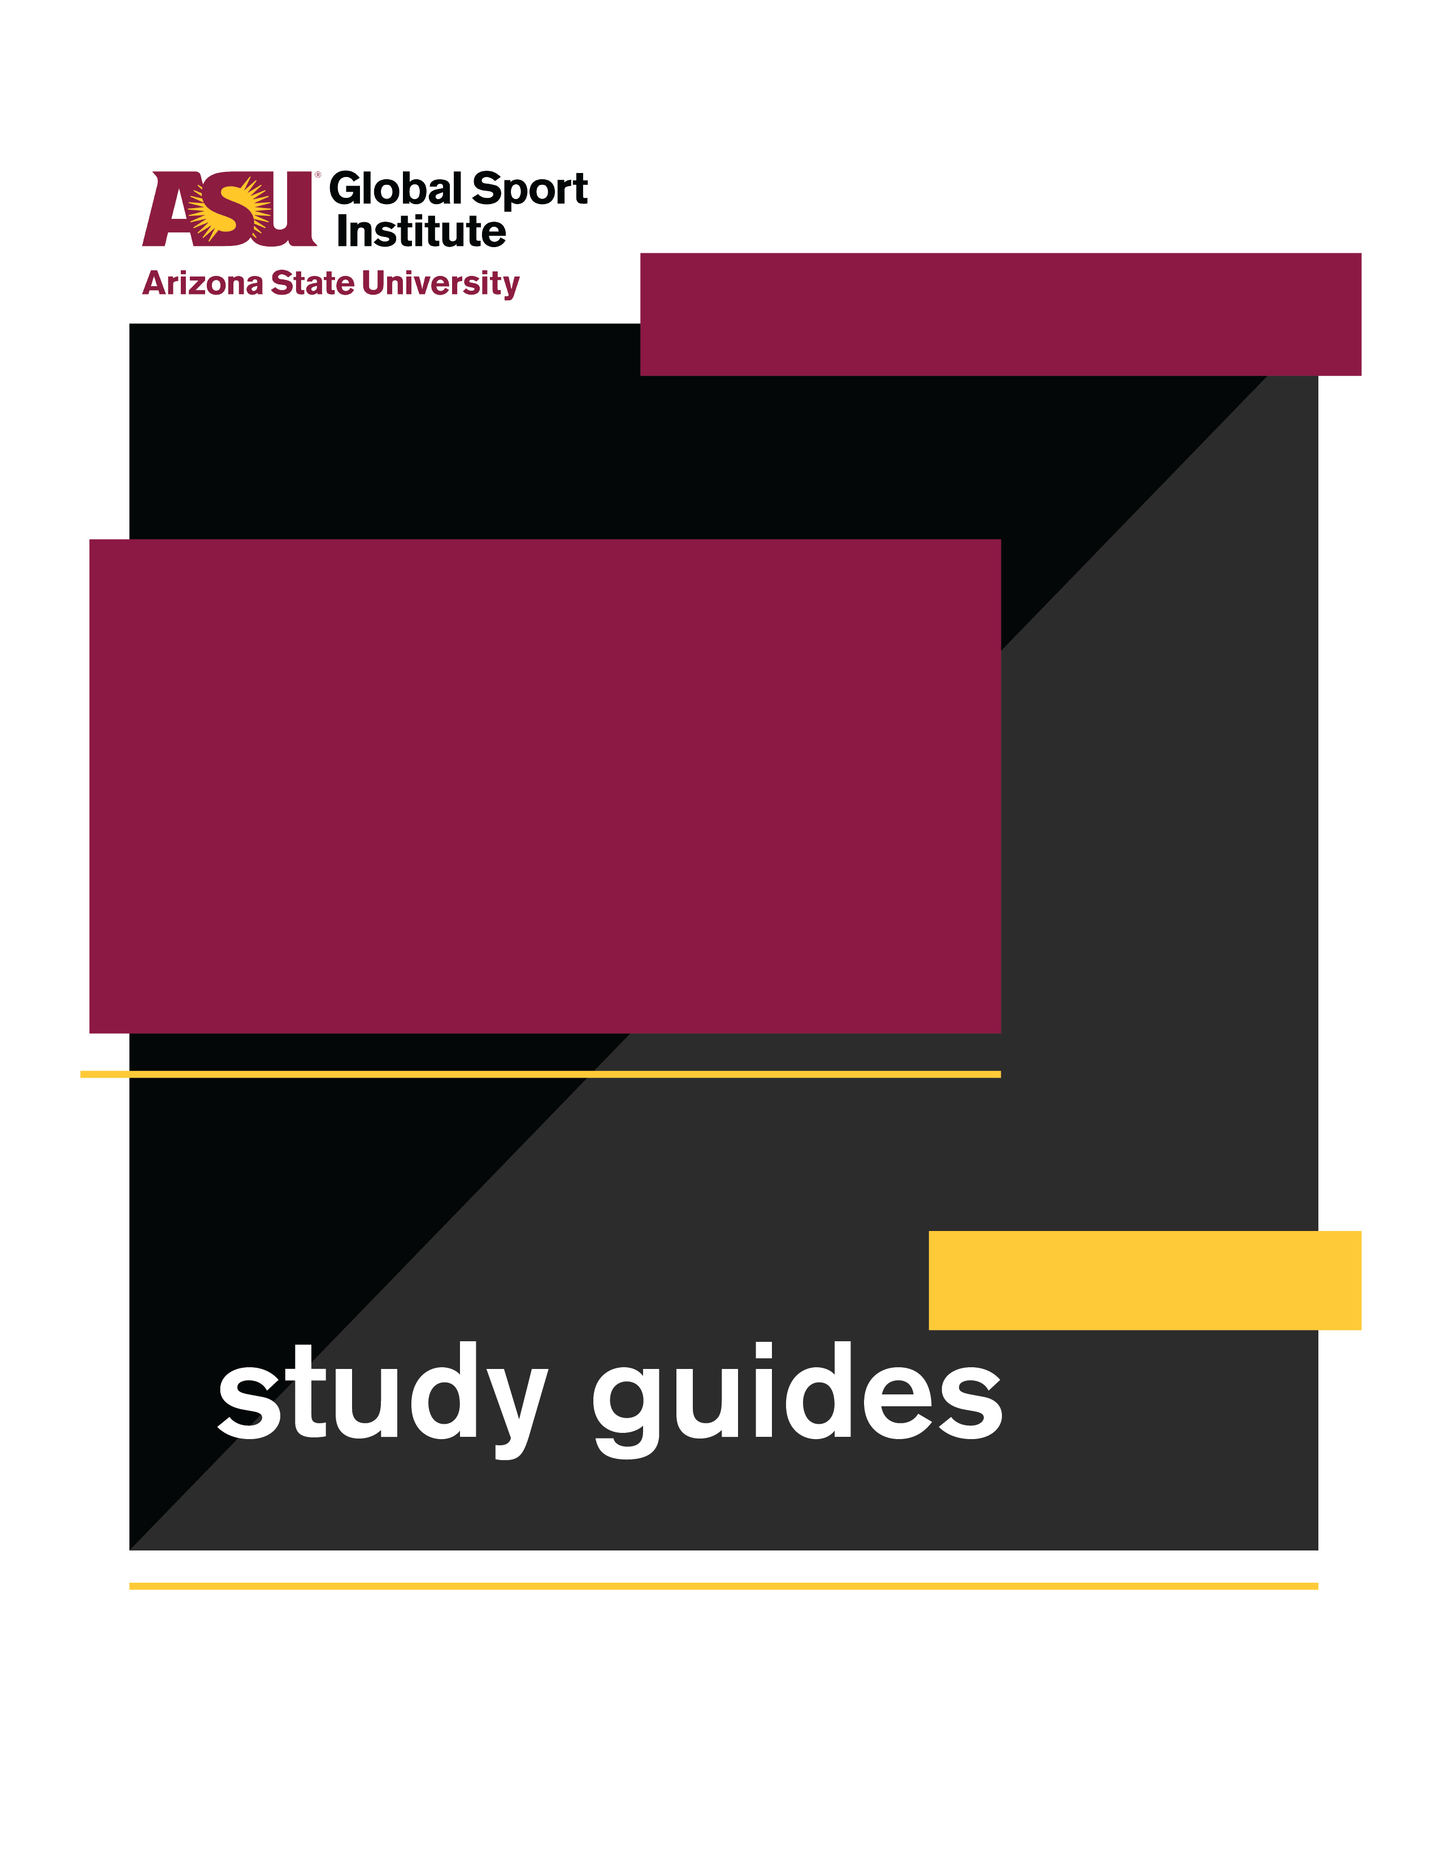
GROUP WORKSHEET
Still Got Game

Directed by
Pamela Johnson
This study guide was created by the Global Sport Institute at Arizona State University. https://globalsport.asu.edu
Documentary Study Guides

Still Got Game – Group Worksheet
https://www.youtube.com/watch?v=qU3S-BrADEM&feature=youtu.be

While watching this 7-minute documentary, write down answers to the following questions. You’ll also have a few minutes after it’s over to finish your answers.

1. Why did the guys at Toberman park not let Anita play basketball with them?

2. How did education play an important role in Anita’s life?

3. What are some of Anita’s athletic achievements?

4. What are some challenges that Anita has faced throughout her life?

5. Why did Anita want to become a police officer, and what did she achieve as one?

6. How has women’s basketball changed in the last few decades, according to Anita?

7. What happened to the Women’s Professional Basketball League?

Discussion Activities - wait until your teacher prompts you to start this section

- Giving Back: At the end of the documentary when she’s talking about officiating basketball, Anita says, “I’m giving back to this sport, to the young athletes, because the sport gave a lot to me.”
  - What’s something that you love to do?

  - What has it given to you? List and explain 3-4 ways this interest/hobby has helped you, provided something you want or need, benefited you, etc.

  - How can you give back to this interest/hobby? List and explain 2-3 ways you can invest in it, improve it, provide it to more people, etc.

- Learning About You: Anita’s father was Puerto Rican, but she lived in Los Angeles. She played for the Puerto Rican national basketball team at an international tournament when she was in college, and that’s when she went to Puerto Rico for the first time and met her grandmother.
  - What do you think it was like for Anita to visit Puerto Rico, meet some of her family, and play for the Puerto Rican team? Put yourself in her shoes and explain in 3-4 sentences.

  - Think of something about your family history, your hometown or neighborhood, or a loved one that you don’t know much about. This could include a language, family tree, the history of a place, a remarkable story about a relative, a cultural tradition, or something else.
      - What is it that you don’t know much about?

      - If you want to learn more about it, what are 2-3 ways you could start?

      - List and explain 3-4 ways that learning more about this thing would affect your perspectives, relationships, or daily life.

- Race and Ethnicity: “Race is often perceived as something that's inherent in our biology, and therefore inherited across generations. Ethnicity, on the other hand, is typically understood as something we acquire, or self-ascribe, based on factors like where we live or the culture we share with others” (read more from this article here).

Anita talked about having a Black mother from the deep South, and a Puerto Rican father. She grew up in an area with a significant Mexican population and cultural influence.
  - How do you think these factors affected Anita’s identity and experience growing up? Explain in 2-3 sentences.

  - Using the quoted paragraph above as a reference:
    - What is your race? Why?

    - What is your ethnicity? Why?

  - Have you ever thought about the difference between race and ethnicity? What does it make you think about related to who you are and why you wrote the race and ethnicity you did? Explain in 3-4 sentences.

