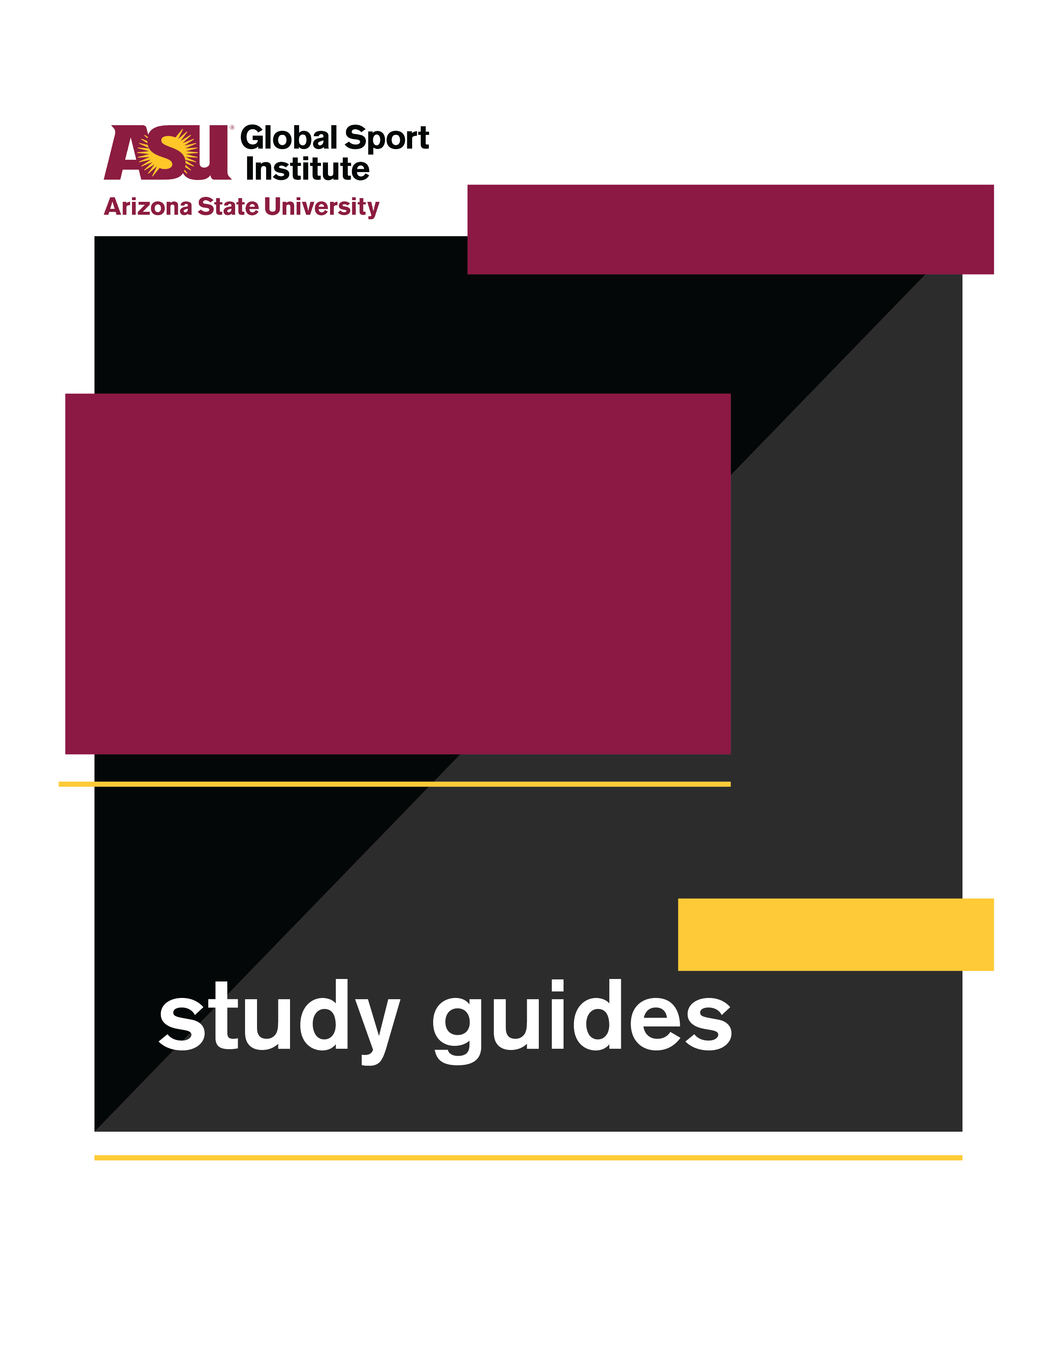
LESSON PLAN
This study guide was created by the Global Sport Institute at Arizona State University. https://globalsport.asu.edu
Soccer Without Borders

Directed by
Orange Lion Productions
Documentary Study Guides

Soccer Without Borders - Lesson Plan
Duration: 35 - 70 minutes with options below
https://globalsportmatters.com/video/2019/02/17/soccer-without-borders-builds-bridges-for-refugee-children/

Black print: Instructions for the teacher
Blue print: Spoken instructions from teacher to participants

Documentary and Worksheet Questions (12-15 minutes)
  - While watching this 11-minute documentary, write down answers to the following questions. You’ll also have a few minutes after it’s over to finish your answers.
  - Provide individual worksheets and start documentary.
    - What are some details the documentary cites about the refugee crisis?
      - In 2015, 60 million people (30 million of them children) were displaced around the world.
      - Resources or more information:
        - UNHCR | What is a refugee?
        - International Rescue Committee
    - What is the goal of Soccer Without Borders (SWB)?
      - It uses soccer, education, and community based activities to support refugee and immigrant youth in reaching their full potential.
      - Soccer Without Borders website
    - What are the five rules of the program?
      - Practice English, have fun, safe space, try everything, and respect
    - Why do students participate in the program?
      - Some students have already played soccer in their villages or camps, and it’s something they love and can pick up. Others participate for support in learning English and in academics, or for the social aspect of it.
    - How is SWB funded and supported?
      - They receive some funding from the government, school districts, and the Department of Education. They are also supported by local foundations and organizations.
    - What are some of the measurements of success for SWB?
      - In the last 10 years, regular participants graduated from high school at a rate of 95%.
      - Coaches also consider success in terms of developing confidence and achieving their potential.

2. Discussion Questions (5-15 minutes)

- Why do you think the regular participants in Soccer Without Borders have such a high graduation rate, at 95%?

- In the documentary, the Soccer Without Borders staff talked about how soccer is capable of “unique, powerful, embedded learning.” The examples they used included teamwork and team roles, power to make decisions, positive attitude, striving for improvement, having control over part of their lives, leadership skills, and learning from failure.

- Think about an activity or skill you enjoy and/or know a lot about (playing music, gardening, fixing things, taking care of kids, or a different sport). What are some lessons that come from it - some “unique, powerful, embedded learning?”
  - Open discussion with full group.
  - Option to have students write/type their individual answers first.
  - Option for small group work/sharing before open discussion with full group.

- How do you think the Soccer Without Borders staff balances and integrates the various cultural differences of the children and families they serve? What did you see related to this in the documentary, and how else could they help people from different areas of the world work together?

3. Worksheet Discussion Activities (15 - 35 minutes - can eliminate 1 if needed for time)

- Rules for Success: Soccer Without Borders has five rules: 1. practice English; 2. have fun; 3. safe space; 4. try everything; 5. respect. Notice they are all actions/verbs.
Think about the same activity or skill you enjoy from our previous discussion question (or a new one if you prefer). If you were starting a club or organization around this activity or skill, what are 4-5 rules you would emphasize for people who joined? Write them on your worksheet, and offer 1-2 sentences for each rule explaining why it’s important. Each rule should include an action/verb like SWB’s rules.
  - Have students write/type rules and reasons on worksheet
  - Discuss as full group
  - Option for small groups before opening full group discussion

- Integrated Programming: Soccer is just one of the reasons kids show up to Soccer Without Borders, and just one of the ways they benefit from being there. List off the other aspects of SWB programs that help attract and benefit refugee kids.
  - Write/type students’ answers on board/discussion forum
  - Final list should at least include the following:
    - Soccer
    - English language education
    - Free meal
    - Academic support / tutoring
    - After school programming
    - Social time with peers
Look how varied this list is - some of these things don’t seem to have anything to do with each other! Write this full list of items under the left AND right columns on your worksheet, creating two identical columns with the same words. Then, draw lines from words in the left column to words in the right column if you think that one item helps SWB kids to participate in another item. For example, if you think “Soccer” helps the kids participate in “English language education,” draw a line from “Soccer” on the left to “English language education” on the right. On every line you draw, write a short phrase explaining how the item on the left helps kids participate in the item on the right. In our example, you could write, “learn soccer vocabulary.”
    - Option for small group work instead of individual
    - While students are working, write/type parallel columns on board/discussion forum to prepare for group debrief
  - Full group debrief
    - Let’s hear some of your answers.
    - Draw lines and write/type phrases across board/discussion forum
Looking at all of this, what does it mean to you? Answers/prompts could include:
  - Some are attracted by the soccer/English/free meal/etc., but they get the benefits of all of these things. There are many reasons why someone would show up in the first place, but then they get to experience all of them.
    - Example: Hassan and Abdullah (twins) love soccer now, but didn’t play before they first came to SWB for other programs.
    - Some come for soccer and learn English faster than their parents because of it.
  - Many of them seem to socialize and make friends with other kids who have shared experiences as refugees.
What is important about the specific things SWB offers to the refugee kids?
  - They fill specific needs that these kids are likely to have.
    - English language learning
    - Safe space
    - Help with schoolwork in a new school system and language
    - Socializing with kids who have experiences in common with them
    - After school spaces and meals - when parents are likely working strange/long hours and have low-income when getting started in the U.S.

4. Conclusion (3-5 minutes)

- What did you learn about the challenges refugees face?
- What did you learn about providing programming for populations with a wide range of needs?
- What did you learn about the power of sport?
- How might greater awareness about the issues we learned and talked about improve the world?

