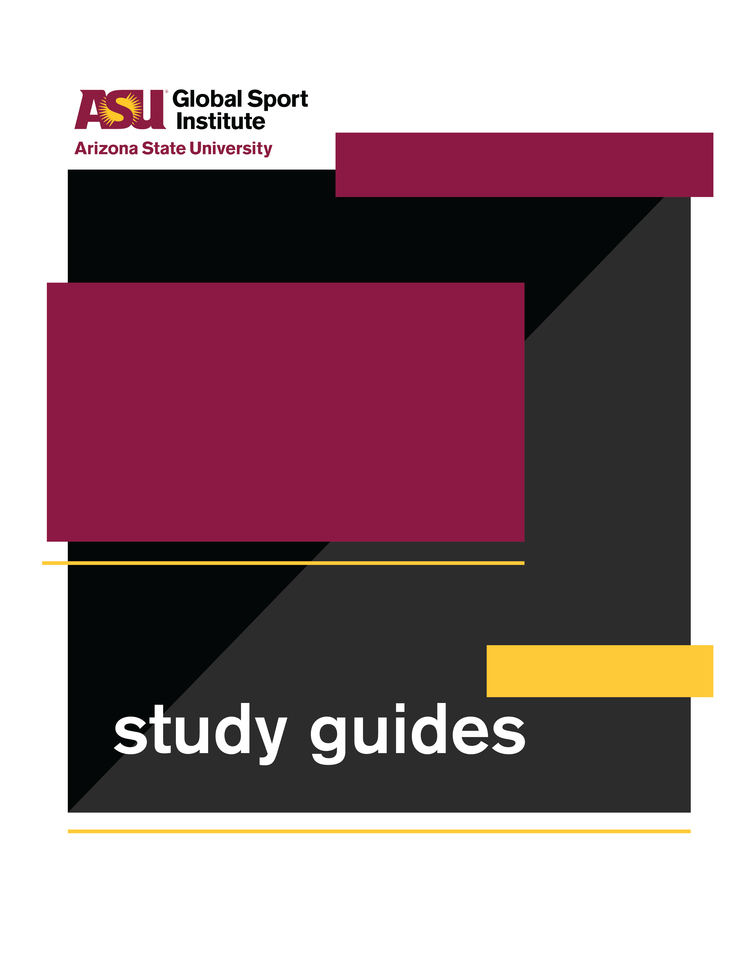
GROUP WORKSHEET
This study guide was created by the Global Sport Institute at Arizona State University. https://globalsport.asu.edu
Soccer Without Borders

Directed by
Orange Lion Productions
Documentary Study Guides

Soccer Without Borders – Group Worksheet
Duration: 35 - 70 minutes with options below
https://globalsportmatters.com/video/2019/02/17/soccer-without-borders-builds-bridges-for-refugee-children/

Answer each of the following questions with bullet points or short sentences as you watch the 11-minute documentary. You’ll have a few minutes after watching to finish answering.

- What are some details the documentary cites about the refugee crisis?

- What is the goal of Soccer Without Borders (SWB)?

- What are the five rules of the program?

- Why do students participate in the program?

- How is SWB funded and supported?

- What are some of the measurements of success for SWB?

Discussion Activities - wait until your teacher prompts you to start this section

- Rules for Success: Soccer Without Borders has five rules: 1. practice English; 2. have fun; 3. safe space; 4. try everything; 5. respect. Notice they are all actions/verbs. Think about the same activity or skill you enjoy from our previous discussion question (or a new one if you prefer). If you were starting a club or organization around this activity or skill, what are 4-5 rules you would emphasize for people who joined? Write them on your worksheet, and offer 1-2 sentences for each rule explaining why it’s important. Each rule should include an action/verb like SWB’s rules.
  - Rule #1: _________________________________
    - Reason:

  - Rule #2: __________________________________
    - Reason:

  - Rule #3: _________________________________
    - Reason:

  - Rule #4: _________________________________
    - Reason:

  - Rule #5: _________________________________
    - Reason:

- Integrated Programming: Soccer is just one of the reasons kids show up to Soccer Without Borders, and just one of the ways they benefit from being there. Look at how varied the list is that your class created. Some of these things don’t seem to have anything to do with each other!
Write this full list of items under the left AND right columns below. Then, draw lines from words in the left column to words in the right column if you think that one item helps SWB kids to participate in another item. For example, if you think “Soccer” helps the kids participate in “English language education,” draw a line from “Soccer” on the left to “English language education” on the right. On every line you draw, write a short phrase explaining how the item on the left helps kids participate in the item on the right. In our example, you could write, “learn soccer vocabulary.”

Left Column Right Column

__________________ __________________

__________________ __________________

__________________ __________________

__________________ __________________

__________________ __________________

__________________ __________________

__________________ __________________

__________________ __________________

__________________ __________________

__________________ __________________

__________________ __________________

__________________ __________________

__________________ __________________

__________________ __________________

