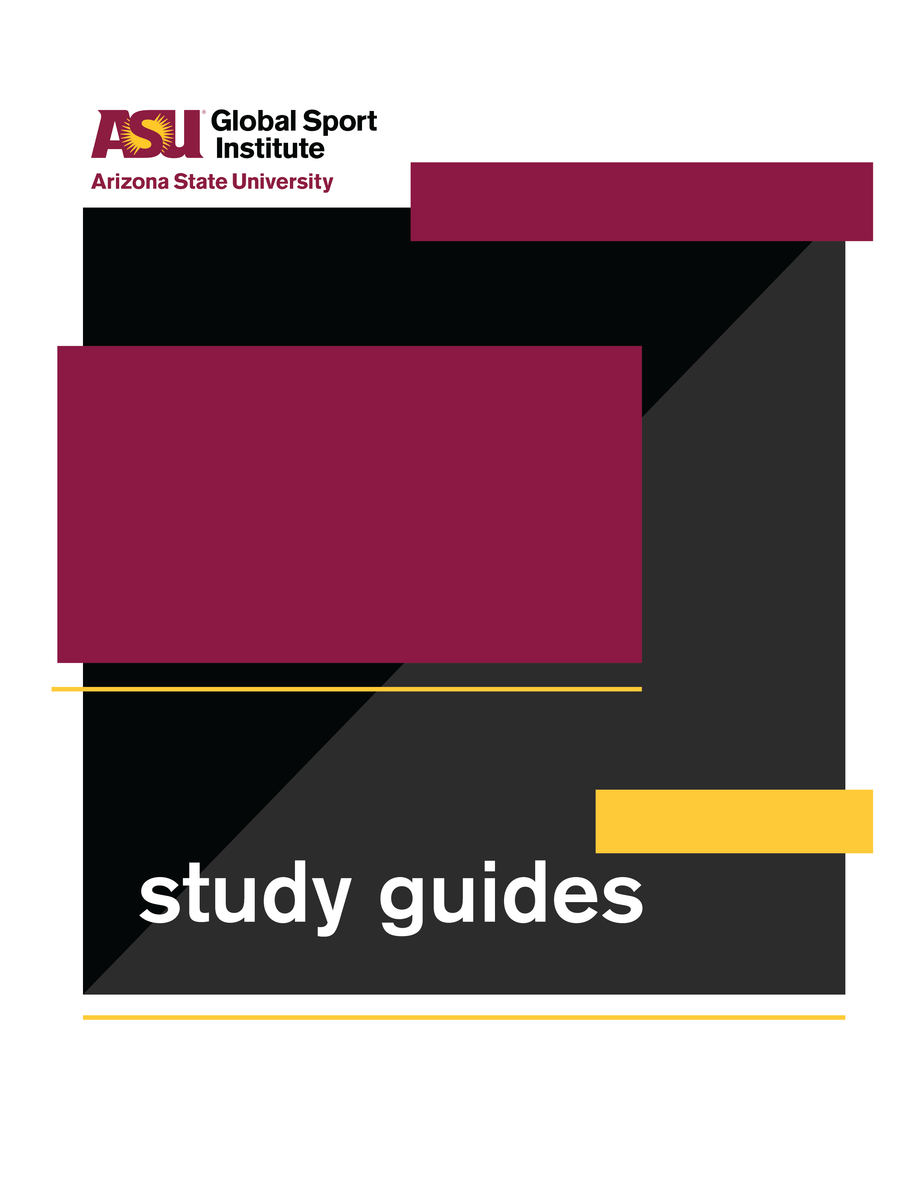
INDIVIDUAL VIEWING
GUIDE
This study guide was created by the Global Sport Institute at Arizona State University. https://globalsport.asu.edu
Reyana’s Journey

Directed by
Pamela Johnson

Documentary Study Guides

Reyana’s Journey – Individual Viewing Guide
Directed by Pamela Johnson
Duration: 40 - 90 minutes with options below
https://globalsportmatters.com/video/2018/05/24/video-reyanas-journey/

Watch and Answer
While watching this 9-minute documentary, write down answers to the following questions. You can finish your answers after the documentary if you need more time. Answers are pasted at the end of this viewing guide for your reference.

- What opportunities did tennis provide for Reyana?

- What was Apartheid in South Africa? Give 2-3 examples of how it was enforced?

- What were some of the ways Reyana and her family improvised to be able to play tennis growing up?

- What was the result of Reyana protesting and boycotting as a student?

- What did Reyana’s father do to try and provide more opportunities for his daughter?

- How long was Nelson Mandela in prison, and what did he become when he was released in 1990?

- What are some of Reyana’s tennis accomplishments?

- Why did Reyana say it was “bittersweet” to watch her daughter play tennis in South Africa?

Think About It

- We see images of protests, riots, and boycotting throughout the documentary. Reyana talks about going to the protests at 14 years old.
Have you ever participated in a protest? What was the cause? How did it feel to be part of a protest? Why did you participate? If you haven’t been involved in a protest, is there a reason you haven’t? What are your thoughts about protests? Do you think you’ll ever participate in one? Why or why not?

- What do you think Reyana’s life would have looked like had she stayed in South Africa? Consider political events, racial tensions, sport opportunities, and Mandela’s release.

- How do you think Reyana’s experience would have been different if she were:
  - A white male?
  - A white female?
  - A Black male?

- What do you think are some of the challenges that international student athletes face as they transition to college, a new sports environment, and a new country and culture? List and explain 3-4 challenges.

- Reyana talked about how her mom had lighter skin than her dad and could do more in society because of it. Also, the documentary featured images of signs that told people where they could and couldn’t be based on their skin color. How do you think it affects a child to grow up in a society that openly prioritizes and restricts people based on their race?

- Think about what you saw about how Apartheid was enforced in South Africa. Where and when else are you aware of these types of discrimination happening around the world?

Apply It

- Reyana discusses attending protests when she was 14 to fight Apartheid. Think of something you are passionate about. Create a short action plan on how you would raise awareness and make a difference for this issue or cause. Think about what resources you can use, who you would get involved, and what your desired outcome would be. (Examples: raising awareness about homeless youth, doing a clothing drive at your school)
  - What is the issue or cause, and who/what will benefit from your work on it?
  - What is the desired outcome or goal? It can be big or small!
  - What physical/tangible resources do you need?
  - What are 2-3 potential challenges you could face, and how would you plan to overcome them?
  - What are the first steps you need to take to make this impact?

- Reyana talks about a connection between her life and Nelson Mandela’s. She juxtaposes feeling trapped in South Africa and Mandela being imprisoned on Robben Island. Both eventually emerged from this trapped state of life and moved on to better and brighter futures. Think of an athlete, celebrity, leader, or someone you know whose personal journey you connect with. Write a fake letter to this person explaining your connection, how they have impacted your life, and what positive lessons you have learned from them. Make it at least two paragraphs. This letter is for you to keep and will not be mailed.

- Reyana was the first black South African to get a scholarship playing college tennis, but she talked about being accused of leaving for the U.S. during her country’s fight for freedom and justice. Put yourself in her shoes:

  - Explain two reasons why you should go to college in the U.S
  - Explain two reasons why you should stay in South Africa.
  - List a couple sacrifices you’d have to make with EACH decision.
  - Who would be disappointed or angry with you for EACH decision?
  - When you face a difficult decision that affects you and other people, what considerations do you make? Explain in 3-5 sentences.

Conclusion

- What was the most interesting thing you learned from Reyana’s Journey?
- How have things changed in South Africa since Reyana left and when she brought her daughters back? What differences do you see?
- How might greater awareness about Apartheid, freedom, and protests improve the world?

Worksheet Answer Key

What opportunities did tennis provide for Reyana?
She got more access to education, was able to study in the U.S., and met her husband.

- What was Apartheid in South Africa? Give 2-3 examples of how it was enforced?
In South Africa, Apartheid was a system of racial segregation enforced by the government from 1948-1991. People were separated in various aspects of their lives from where you lived, what train you could take, and what beach you were allowed to go to.

- What were some of the ways Reyana and her family improvised to be able to play tennis growing up?
Her father bought a ball machine, they played without nets and/or made nets out of pantyhose

- What was the result of Reyana protesting and boycotting as a student?
Reyana, along with some other students, were not permitted to come back to school.

- What did Reyana’s father do to try and provide more opportunities for his daughter?
Reyana’s father wrote to various political and athletic leaders such as Desmond Tutu, Andrew Young, and Arthur Ashe (all three fought against Apartheid). He used sport as a vehicle for more opportunities for his daughter and was able to get her a scholarship to Georgia State University.

Click the links for more information on these leaders mentioned in the documentary.
Desmond Tutu is a South African Anglican cleric, bishop, theologian, and Nobel Peace Prize Winner known for his work as an anti-apartheid and human rights activist.
Andrew Young Jr. is an American politician, diplomat, and civil rights activist.
Arthur Ashe was an American professional tennis player who won three Grand Slam singles titles. Ashe was the first black player selected to the United States Davis Cup team and the only black man ever to win the singles title at Wimbledon, the US Open, and the Australian Open.

- How long was Nelson Mandela in prison, and what did he become when he was released in 1990?
He was in prison for 27 years. After he was released, he became President of South Africa

- What are some of Reyana’s tennis accomplishments?
Reyana was number one on her team and captain her senior year. She had won her conference three out of the four years that she was at Georgia State. She briefly played pro.

- Why did Reyana say it was “bittersweet” to watch her daughter play tennis in South Africa?
Her daughter had opportunities that she did not because South Africa has made progress, but she remembers being denied access to playing on those exact same tennis courts as a girl.

