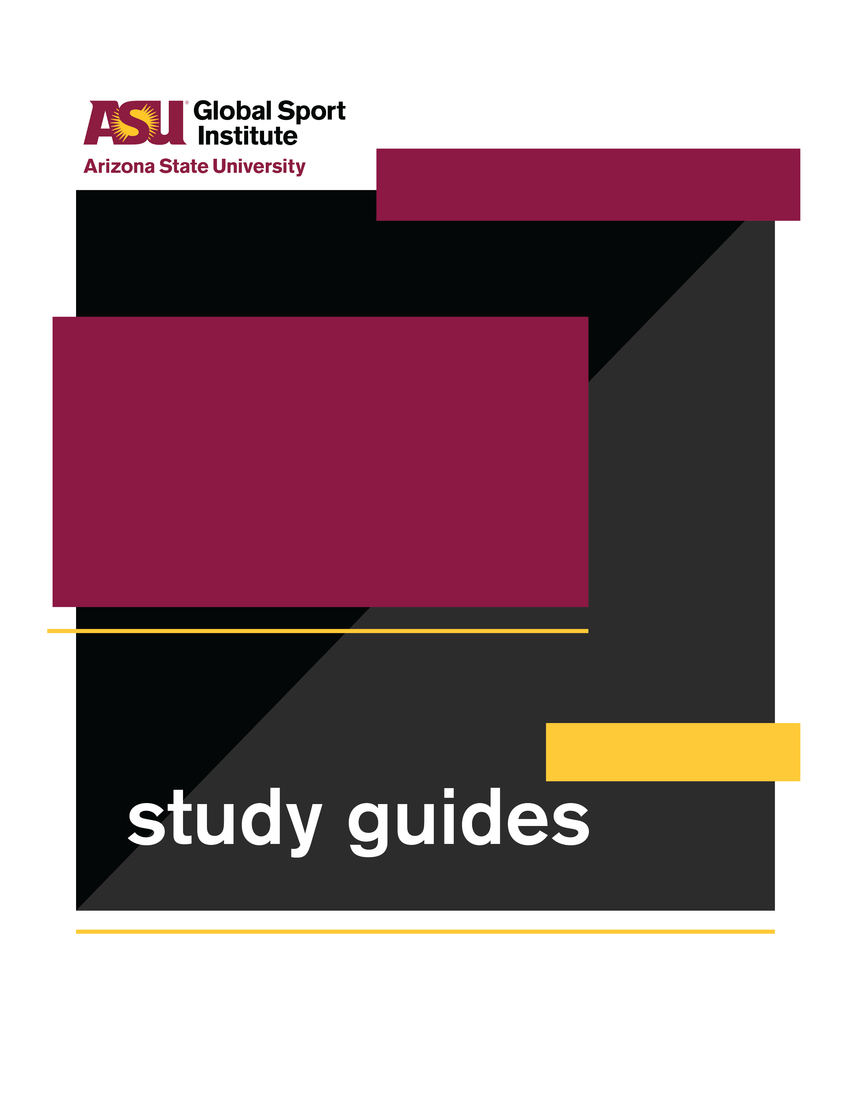
GROUP WORKSHEET
This study guide was created by the Global Sport Institute at Arizona State University. https://globalsport.asu.edu
Reyana’s Journey

Directed by
Pamela Johnson

Documentary Study Guides

Reyana’s Journey – Group Worksheet
Directed by Pamela Johnson
Duration: 40 - 90 minutes with options below
https://globalsportmatters.com/video/2018/05/24/video-reyanas-journey/

Answer each of the following questions with bullet points or short sentences as you watch the 9-minute documentary. You’ll have a few minutes after watching to finish answering.

- What opportunities did tennis provide for Reyana?

- What was Apartheid in South Africa? Give 2-3 examples of how it was enforced?

- What were some of the ways Reyana and her family improvised to be able to play tennis growing up?

- What was the result of Reyana protesting and boycotting as a student?

- What did Reyana’s father do to try and provide more opportunities for his daughter?

- How long was Nelson Mandela in prison, and what did he become when he was released in 1990?

- What are some of Reyana’s tennis accomplishments?

- Why did Reyana say it was “bittersweet” to watch her daughter play tennis in South Africa?

Discussion Activities- wait until your teacher prompts you to start this section

- Reyana discusses attending protests when she was 14 to fight Apartheid. Think of something you are passionate about. Create a short action plan on how you would raise awareness and make a difference for this issue or cause. Think about what resources you can use, who you would get involved, and what your desired outcome would be. (Examples: raising awareness about homeless youth, doing a clothing drive at your school)
  - What is the issue or cause, and who/what will benefit from your work on it?
  - What is the desired outcome or goal? It can be big or small!
  - What physical/tangible resources do you need?
  - What are 2-3 potential challenges you could face, and how would you plan to overcome them?
  - What are the first steps you need to take to make this impact?

- Reyana talks about a connection between her life and Nelson Mandela’s. She juxtaposes feeling trapped in South Africa and Mandela being imprisoned on Robben Island. Both eventually emerged from this trapped state of life and moved on to better and brighter futures. Think of an athlete, celebrity, leader, or someone you know whose personal journey you connect with. Write a fake letter to this person explaining your connection, how they have impacted your life, and what positive lessons you have learned from them. Make it at least two paragraphs. This letter is for you to keep and will not be mailed.
- Reyana was the first black South African to get a scholarship playing college tennis, but she talked about being accused of leaving for the U.S. during her country’s fight for freedom and justice. Put yourself in her shoes:
  - Explain two reasons why you should go to college in the U.S
  - Explain two reasons why you should stay in South Africa.
  - List a couple sacrifices you’d have to make with EACH decision.
  - Who would be disappointed or angry with you for EACH decision?
  - When you face a difficult decision that affects you and other people, what considerations do you make? Explain in 3-5 sentences.

