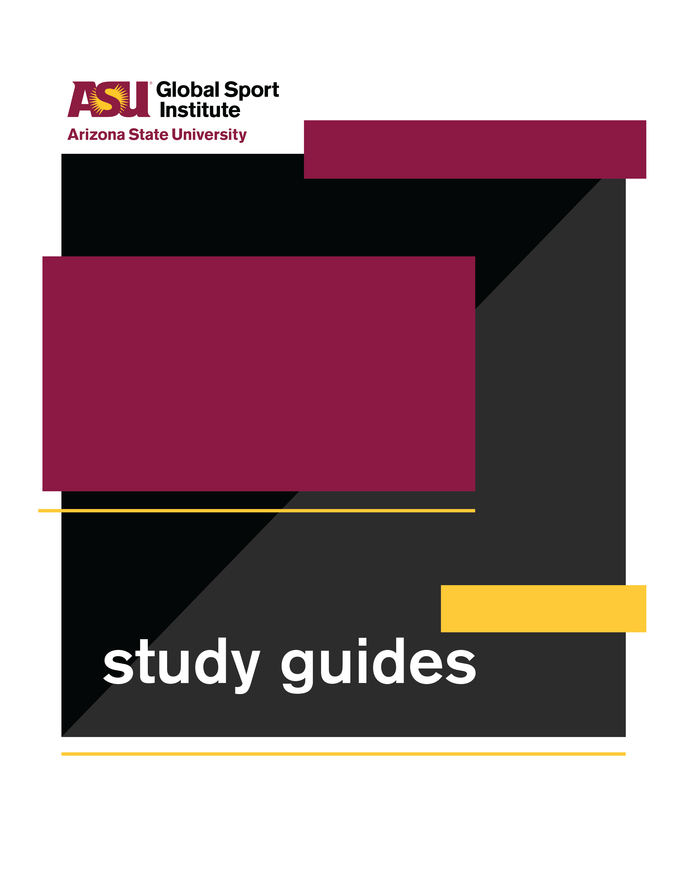
LESSON PLAN
This study guide was created by the Global Sport Institute at Arizona State University. https://globalsport.asu.edu
Race for the Safest Helmet

Directed by
Orange Lion Productions

Documentary Study Guides

Race for the Safest Helmet - Lesson Plan
Directed by Orange Lion Productions
Duration: 35 - 90 minutes with options below https://globalsportmatters.com/video/2019/01/18/the-race-to-create-the-safest-football-helmet/

Black print: Instructions for the teacher
Blue print: Spoken instructions from teacher to participants

- Documentary and Worksheet Questions (15-20 minutes)
  - While watching this 14-minute documentary, write down answers to the following questions. You’ll also have a few minutes after it’s over to finish your answers.
  - Provide individual worksheets and start documentary.
    - What separates CTE from other kinds of head trauma?
CTE results from repetitive concussive injuries. The repetitiveness of these injuries is what prevents the brain from healing.
    - Why were helmet standards put in place in the 1960s and 1970s?
It was to address the alarmingly high rate of skull fractures suffered by NFL players.
    - What’s the egg metaphor?
The brain is like a yolk, and the skull is like the eggshell. The current padding and design of the helmet allows more force to push the head. The brain then hits the inside of the skull and is injured.
There is a tradeoff between protecting the shell (skull) or the yolk (brain). Current helmets do a better job at protecting the “shell,” as their primary use is to prevent skull fractures, but this neglects the “yolk,” which leads to brain injury.
    - Which industry has crossed over with injury research in sports?
The automotive industry. Metrics from their research have been applied to the construction of safety equipment for sport.
    - What are the different kinds of impact that engineers consider when designing better helmets? (Hint - level of impact and direction of impact)
High energy impacts - involves head to ground and serious head-to-head impact.
        - Linear hit (direct from the side that forces head straight in one direction)
        - Rotational hit (causing head and neck to rotate/twist)
Low energy impacts - hundreds or thousands of smaller hits experienced throughout a season.
    - What are some concerns specific to youth football players?
It’s the majority of football players.
The brain is still developing.
Any sort of trauma has a compounding effect on younger people - the longer you have head trauma, the worse it is for your brain.
    - What is the next step in constructing new, more effective helmets?
Helmets can be customized to match the surface of a player’s head to create best fit helmets.
Sensors can be placed in helmets to gain data, improve metrics, and monitor every impact a player experiences. This can inform coaches.
    - What is the ultimate goal in researching and designing safer helmets, according to the people in the documentary?
Decrease dangers and increase what we know about how to address them.
A co-evolution of safety products and football.

2. Discussion Questions for full-group discussion (10-20 minutes)

- The documentary covered several new developments for helmets, including scanning players’ heads to create customized helmets and monitoring impacts on their heads using real-time sensors. How do you think this will help solve problems of brain trauma in football, and how do you think it will fall short? Consider technological limitations, human interpretation and error, cost and access, etc.
- Do you think kids under 14 years old should play non-tackle football only? Why or why not?
- If you watch football, will what you learned from this documentary affect what you think about when you watch it? If so, what will you think about differently? If not, why not?
  - Potential answers if examples are needed
    - Identifying a rotational hit versus a directional hit
    - Noticing the smaller hits players experience during the game
    - Rules and penalties around hits to the head
- If girls and women played football at equal rates to men and boys, do you think the general population would show more, less, or the same level of concern about CTE? Why?

3. Worksheet Discussion Activities (20-40 minutes - can eliminate 1-2 if needed for time)

- Science metaphors: Scientific information is often difficult to communicate to the public, because it’s complicated, and the vocabulary isn’t something most people use everyday. What was your reaction to the “egg shell and yolk” metaphor for the skull and brain, and the “seatbelt and airbag” metaphor for the helmet shell and padding? Did it help you understand what they were talking about?
  - Discuss how the metaphors represent the science.
  - Clarify any outstanding questions.
  - Think of something that you know a lot about - maybe auto mechanics, playing an instrument, taking care of a person or animal with a specific illness, astronomy, etc. Write down two metaphors that would help people who know little/nothing about this topic understand it better.
    - Use personal example to illustrate.
    - Students write answers on worksheet.
    - Option to break students into small groups to share answers before opening full group debrief.
    - Full group debrief with students reading their metaphors.
- Creating change: The documentary says that brain injuries in football grew from an “NFL story” to a “public health” story, in part because of the movie “Concussion” in 2015 and because of public outcry. This led to widespread critique, eventual changes to NFL policies, reduced rates of youth football participation, and increased innovation among football helmet manufacturers like those featured in the documentary.
  - What are some other examples of this happening in society - a film, political action, or public outcry causing an organization or population to change its behavior?
    - Potential answers if examples are needed:
      - Blackfish (2013) - following its release, SeaWorld and similar wildlife parks changed policies for killer whales due to public pressure. It was kind of like Tiger King (2020) for killer whales, and it proved effective in the years after its release.
      - Colin Kaepernick - several NFL players and teams, and athletes in other sports, took similar action during the U.S. National Anthem, and the NFL has since made donations and established programs around the cause of ethnic minorities and police relations.
    - What’s an issue or cause that you think needs more public attention? How do you want to change people’s attitudes and behaviors? What do you think would create this change? List your ideas on your worksheet.
      - Worksheet prompts:
        - What is the issue or cause?
        - What do you want to change about people’s attitudes and/or behaviors? Be specific!
          - For example, “I want people to stop going to SeaWorld,” or “I want all youth football to be non-tackle until the age of 14.”
        - What would help create these changes you want?
          - Think big! A movie, a celebrity endorsement, a new law?
          - Think small! Community events, a hashtag, supporting a like-minded non-profit with your time or resources?

- Opposing arguments: The following quotes close out the documentary:
  - “There’s going to be a co-evolution of product and the sport as a whole...We know a fairly sure strategy would be to wrap an athlete in bubble wrap and have them go run around and bounce off each other, but that takes away what we love and what’s exciting about the sport.” - Grant Goulet
  - Referring to helmet improvements, “The goal is to decrease the dangers inherent in the sport - and then increase the amount that we know about ameliorating those dangers, and closing that gap as best we can.” - Alan Schwarz
- Should we press “pause” on football until helmets catch up to the dangers of the sport? Until we close the gap farther?
  - Make an argument for “Yes” and “No” with at least three points for each. You must use information from the documentary for some of these points, but not all. Each point should be 1-2 sentences.
    - Potential answers if examples are needed:
      - No - football is a popular form of exercise for many kids, and taking it away could decrease exercise.
      - Yes - until every helmet can monitor real-time impacts, we won’t know how severe the brain trauma is for any football player (kid or adult). We need to wait until everyone has access to this technology.
    - Option to have students develop arguments in small groups before opening full group debrief.
  - Full group debrief
    - Let’s hear some of your points for “yes, we should pause all football until helmets catch up. We will discuss opposing points in a little bit, but not yet.”
      - Write/type on board for full group to see.
      - Alternatively - have students write/type their points on the board/discussion forum.
      - Read and clarify points.
    - Now let’s hear some of your points for “no, football should continue as we develop safer helmets.” Again, we will discuss opposing points later.
      - Write/type on board for full group to see.
      - Alternatively - have students write/type their points on the board/discussion forum.
      - Read and clarify points.
    - Okay - now let’s discuss. Potential questions to ask as you facilitate:
      - Who believes we should pause football? Who believes football should continue? Who isn’t sure?
      - Now is your chance to elaborate on one of your arguments.
      - What was it like writing three arguments for something you didn’t actually believe? What did you feel?
      - If you could compromise between these two sides (pausing football or not), what would it look like? Include ideas that prioritize player health and safety, integrate technology and science, and allow the sport to continue. You do not have to believe this compromise is the best option - just think of ideas.

Conclusion (3-5 minutes)

- What did you learn about football, helmets, and science today?
- What did you learn about communicating science to the public?
- In this case, how did bringing science to the public generate progress?
- How might greater awareness about the issues we learned and talked about improve the world?

