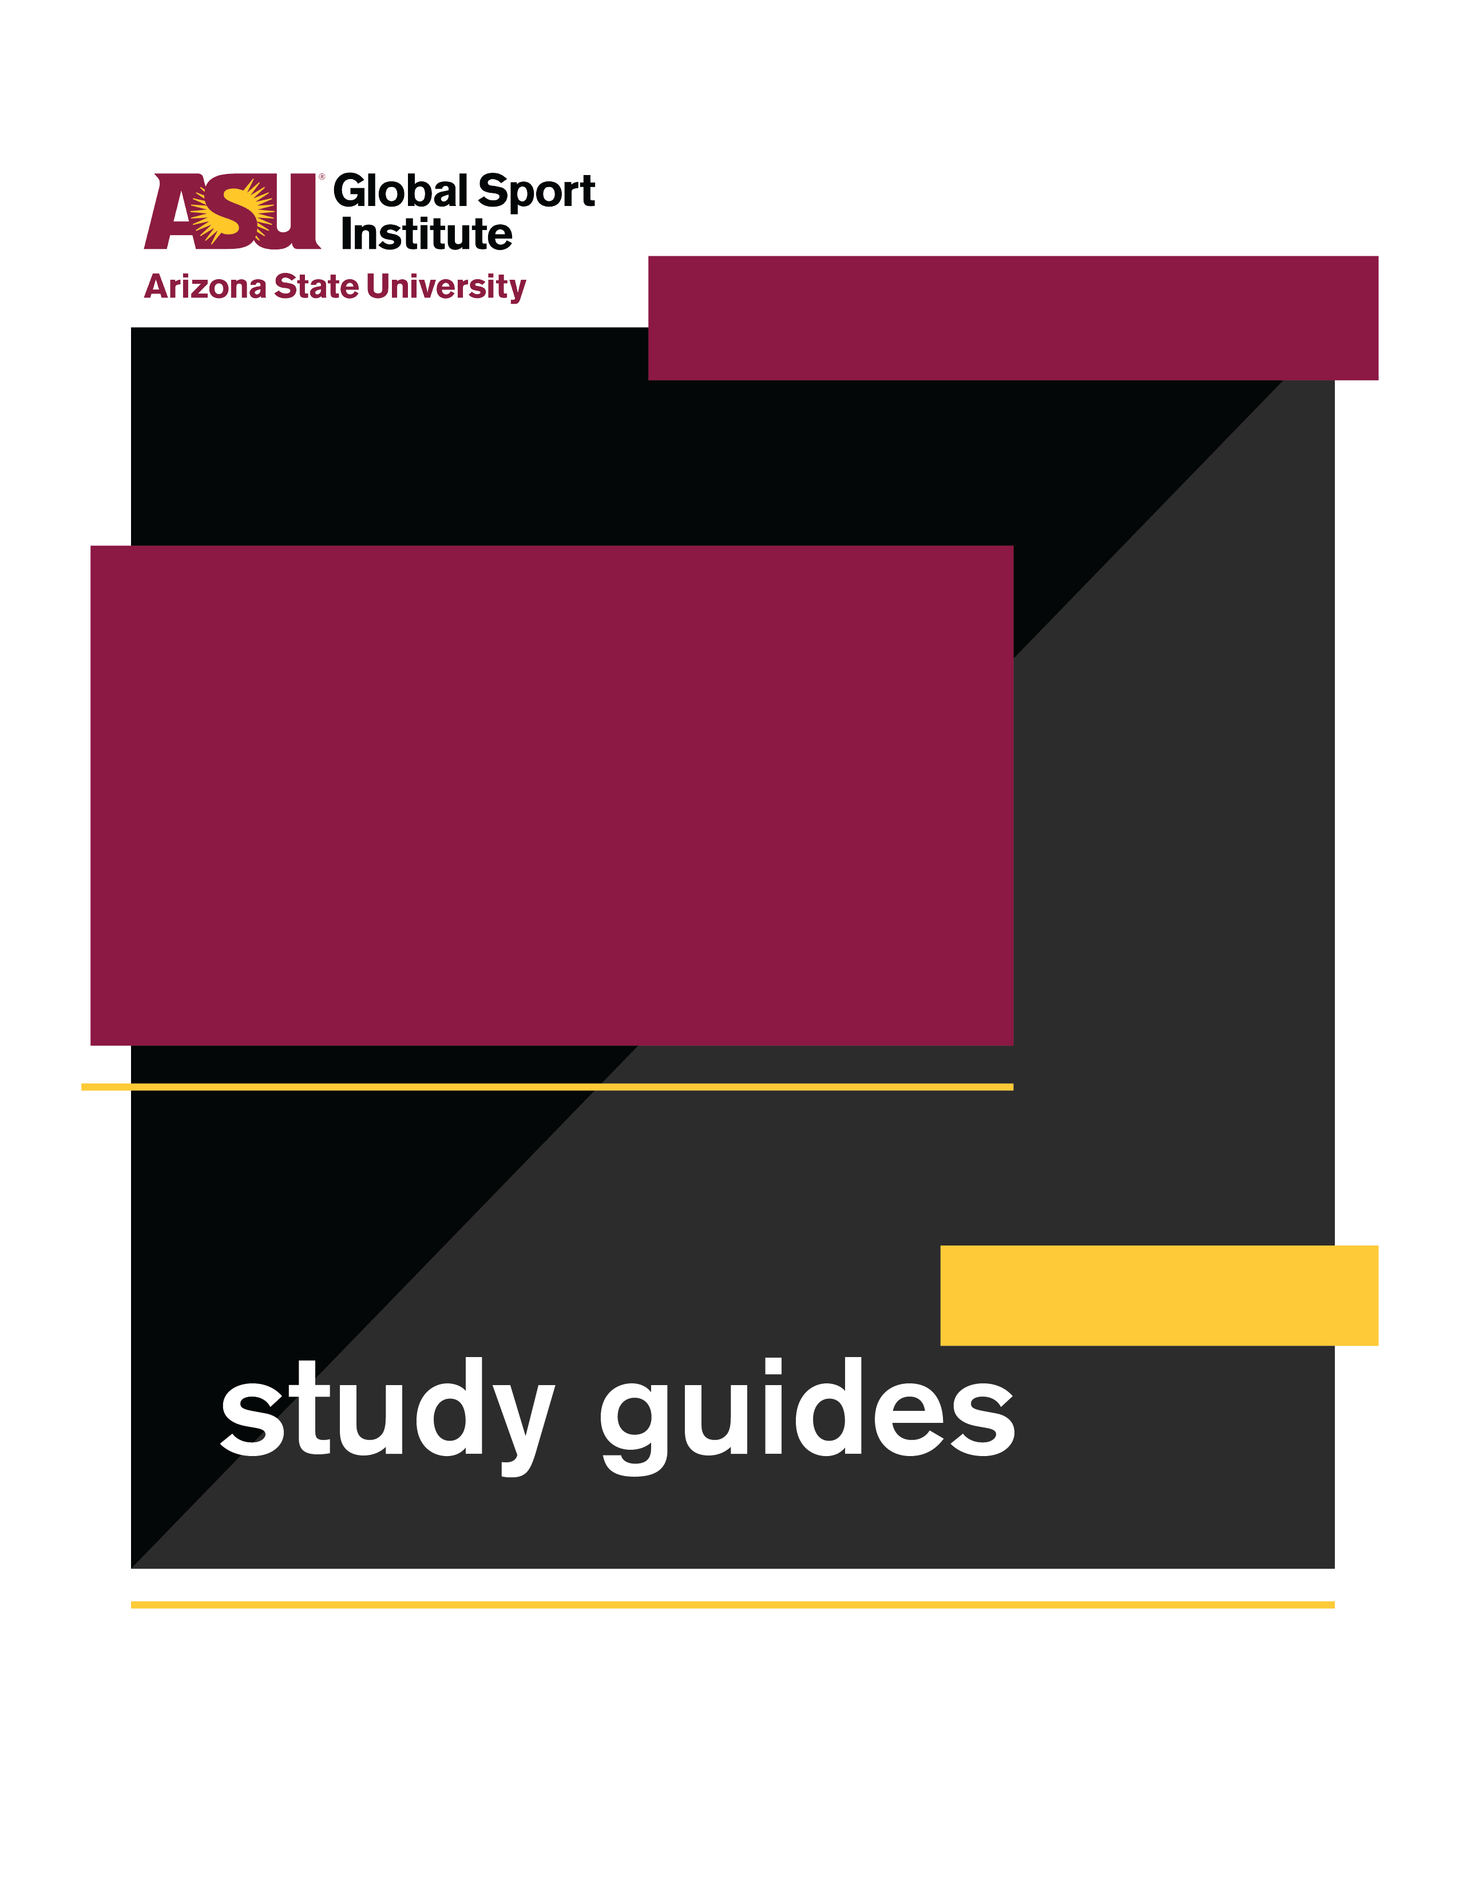
GROUP WORKSHEET
This study guide was created by the Global Sport Institute at Arizona State University. https://globalsport.asu.edu
Race for the Safest Helmet

Directed by
Orange Lion Productions

Documentary Study Guides

Race for the Safest Helmet – Group Worksheet
Directed by Orange Lion Productions
Duration: 35 - 90 minutes with options below https://globalsportmatters.com/video/2019/01/18/the-race-to-create-the-safest-football-helmet/

Answer each of the following questions with bullet points or short sentences as you watch the 14-minute documentary. You’ll have a few minutes after watching to finish answering.

- What separates CTE from other kinds of head trauma?

- Why were helmet standards put in place in the 1960s and 1970s?

- What’s the egg metaphor?

- Which industry has crossed over with injury research in sports?

- What are the different kinds of impact that engineers consider when designing better helmets? (Hint - level of impact and direction of impact)

- What are some concerns specific to youth football players?

- What is the next step in constructing new, more effective helmets?

- What is the ultimate goal in researching and designing safer helmets, according to the people in the documentary?

Discussion Activities - wait until your teacher prompts you to start this section

- Science metaphors - Think of something that you know a lot about - maybe auto mechanics, playing an instrument, taking care of a person or animal with a specific illness, astronomy, etc. Write down two metaphors that would help people who know little/nothing about this topic understand it better.

- Creating change - What’s an issue or cause that you think needs more public attention? How do you want to change people’s attitudes and behaviors? What do you think would create this change? List some ideas below:
  - What is the issue or cause?

  - What do you want to change about people’s attitudes or behaviors? Be specific!
    - For example, “I want people to stop going to SeaWorld,” or “I want all youth football to be non-tackle until the age of 14.”

  - What would help create these changes you want? List at least four ideas.
    - Think big! A movie, a celebrity endorsement, a new law?
    - Think small! Community events, a hashtag, supporting a like-minded non-profit with your time or resources?

- Opposing arguments - Should we press “pause” on football until helmets catch up to the dangers of the sport? Until we close the gap farther? Make an argument for “Yes” and “No” with at least three points for each. You must use information from the documentary for some of these points, but not all. Each point should be 1-2 sentences.

Yes, we should pause all football until helmets catch up, because:
1.

2.

3.

No, football should continue as we develop safer helmets, because:
1.

2.

3.

